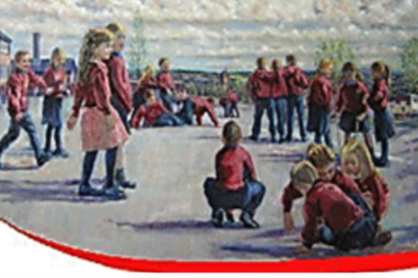

St. Oliver Plunkett Primary School
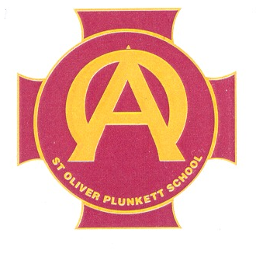
PDMU Policy

Introduction

Our PDMU policy supports the “Every School a Good School” document as it seeks to enable all children to fulfil their full potential by removing barriers to their learning.

“PD & MU places the child at the centre of the curriculum.”

“PD & MU focuses on encouraging each child to become personally, emotionally, socially effective, to lead healthy, safe and fulfilled lives and to become confident, independent and responsible citizens, making informed and responsible choices and decisions throughout their lives.” (NI Revised Curriculum)

In St Oliver Plunkett Primary School, we support the rationale for PDMU as stated in the Revised Curriculum NI document. In today’s challenging and changing society PDMU focuses attention on children’s emotional development, health and safety, relationships with others and the development of moral thinking, values, and actions – as underpinned by the UNCRC. It is fundamental to the development of the whole child.

PDMU is taught as a separate Area of Learning within the Curriculum but also goes beyond this and permeates many of our policies including our Pastoral Care Policy, Behaviour Policy, Healthy Eating Policy, Health and Safety Policy, Inclusion and our Child Protection Policy.

PDMU concentrates on developing each child from Foundation Stage to Year 7. We will help them to broaden their thinking skills and personal capabilities, while making each child emotionally aware and confident in themselves.
We will strive to give our children knowledge in this area, develop positive attitudes and cultivate useful life skills where they will become a valuable member of society.

Rationale

In St Oliver Plunkett Primary School, the delivery of our programme for PDMU is supported by the school’s caring, positive and inclusive ethos, an atmosphere in which all pupils, staff and parents know they are valued.

Healthy children learn well and if young people are healthy, they can take full advantage of every opportunity to learn.

At St. Oliver Plunkett Primary School, we recognize that the pupils in our care grow and develop in many varied ways throughout their primary school education. This ranges from their physical and intellectual growth, to moral, social and emotional growth and development. We strive to meet the needs of all our pupils while they are at school.

Aims.

Our educational philosophy is based on a clear intention to promote all that is best in Catholic Education. A Catholic school is a place where pupils, irrespective of religious affiliation, come to know that they are made from love, to love and be loved. A Catholic school is a place where young people are educated for life and not just for making a living.
We seek to create an atmosphere within our school in which all individuals are cherished and feel valued, is conducive to learning and which seeks to promote the values, beliefs and practices of our faith.
We are a caring school, whether pupils, parents, staff, governors, church or community, feel valued, and are aware of the important contribution each has to make to ensure the continued success of the school.
The whole community within the school shares a common goal – to provide the best possible educational provision for the pupils attending the school. In St Oliver Plunkett Primary School, there is a clear emphasis on the development of self-esteem and team spirit.
We offer our pupils a curriculum which:-
· promotes their spiritual, moral, cultural, intellectual and physical development;
· prepares them for the opportunities, responsibilities and experiences they may meet in their lives.
We endeavour to provide a safe learning environment in which the health, safety and emotional wellbeing of our pupils are of the utmost importance. We encourage within our pupils the growth of desirable qualities such as self-esteem, tolerance, consideration and respect for others.
Parents and people from the local community are often invited into the school to share their expertise and views with the children as well as to celebrate school masses, religious sacraments, assemblies, and concerts with the children. This close partnership is fundamental in promoting PDMU as children are greatly influenced by society’s values, the values communicated in school and also the values held at home.

In St. Oliver Plunkett Primary School, our PDMU programme is aimed at encouraging children to:-
- Develop personally, emotionally, socially and physically.
- Lead healthy, safe and fulfilled lives.
- Develop the skills, attitudes and values to enable them to become more independent, making informed decisions and taking increasing responsibility for their own lives.
- Gain an understanding of their contributing role in society.
- Gain an understanding of the UNCRC and how everyone shows respect for these rights through their actions and beliefs.

PDMU has major benefits for the school and the local community as it helps:
- Build self esteem
- Develop confidence
- Promote health awareness: healthy eating, exercise, drug and alcohol awareness etc…
- Working in a team and consideration for others feelings and valuing other people, looking at the effects that bullying can have on a person’s life.
- Fostering social skills and how one should behave in particular situations.
- Respect for all people no matter their culture, disability. Intelligence level, race etc…
- Making good and informed choices in life, knowing right from wrong, and who to turn to if one needs help advice or just someone to listen to them.

Objectives

Through PDMU we intend to:-
· Deliver the two interconnected strands and teach and explore all nine statutory statements of minimum requirement, from Foundation stage to Year 7.
· Integrate the “Living. Learning. Together Programme”, “Sesame Tree” and “The Media Initiative Programme” to help support the teaching and learning of PDMU.
· Help the children to learn about themselves, how they fit into society, how they learn and how they deserve to be respected and valued.
· To develop children’s self-esteem, self-confidence and self-worth.
· Give the children the tools to help them manage their feelings and emotions.
· Encourage our children to be motivated and ambitious young people with a desire to succeed, no matter the task.
· Ensure that all children are aware of the dangers in our society e.g. drugs, alcohol, bullying, abuse etc.
· Promote good relationships with family and friends.
· Promote working as an individual, in pairs and in groups, to encourage the children to develop their own ability to express themselves in a variety of different ways.
· Encourage children to follow a healthy lifestyle and to keep safe.
· Understand why rules are needed, how to act responsibly and how to deal with conflict effectively.
· Develop an awareness of peoples’ similarities and differences, being respectful of peoples’ beliefs and cultures and be aware of the diversity in our society.
· Encourage the children to become moral and just citizens, taking responsibility for their own actions and how ones’ actions can impact on society.
· Encourage our children to be more tolerant and patient of others.

A caring and positive classroom environment is an essential basis for supporting PDMU. A positive learning environment allows children to express their thoughts and views honestly and openly. In St. Oliver Plunkett Primary School, we use a range of strategies to create a safe and secure environment that encourages children to participate and contribute to their learning.

For PDMU to be effective in our school the teachers will develop and explore through:-
- Active and participatory learning methods: pupils will experience learning for themselves, they will have an interest and increased understanding of their learning and the importance of learning.
- Follow issue based approaches: pupils will explore a greater understanding of the complex nature of certain issues, which are relevant, local, global and current in the lives of the pupils.
- Explore pupils’ and society’s attitudes and beliefs: pupils will begin to take responsibility for their own values and actions, having an awareness of what is right and wrong and be aware of Human Rights and how this can impact on the school, local and global communities.
- Managing Conflict: pupils will learn to manage their own emotions and that of others, showing sensitivity and to show understanding of controversial or sensitive issues.

Active learning Methodologies to support teaching and learning

The teachers will use a wide variety of methods to support PDMU lessons throughout the course of each year:
- Brainstorming
- Role play
- Visitors to the class
- Drama
- Co-operative games
- Photographs, picture stimuli
- Media and television
- Open ended questioning and statements
- Debates: with agree and disagree continuums
- Circle time: which will be developed as a whole school area
- Story telling
- Collage work
- Freeze frames
- Hot seating

How will it be delivered?
Personal Development and Mutual Understanding will be delivered as an individual subject area with time set aside on each class’ weekly timetable. It will also be developed through all other areas of the Revised Curriculum.
Teachers will deliver PDMU by using the nine strands throughout the school year to develop all areas within the Living Learning Together Programme. As a whole staff we will adapt these lessons for each year group and their own class, through year group planning and in discussion with the PDMU coordinator and the school’s Senior Leadership Team.

Children are expected to acquire skills and knowledge from nine statutory statements within these two strands:

Strand One: Personal Understanding and Health
1. Self-awareness
2. Feelings and Emotions
3. Learning to Learn
4. Health, Growth and Change (4a) Safety

Strand Two: Mutual Understanding in the Local and Wider Community
5. Relationships
6. Rules, Rights and Responsibilities
7. Managing Conflict
8. Similarities and Differences
9. Learning to live as members of the community

These areas will be built up in a spiral manner as they will be revisited in each key stage. The children’s skills will develop and progress through each year band. Teachers will use a variety of teaching styles such as individual, paired and group activities to help in the delivery of this subject area, looking at effective ways to link PDMU into the whole curriculum, via class discussion, topic work, circle time, cooperative games, and an agreed set of class rules etc.

All teachers will create a learning environment built on trust which will lead towards a positive learning climate.

Cross Curricular Links

Each area of the curriculum has a contribution to make to PDMU. In St. Oliver Plunkett Primary School staff link whichever curricular areas are appropriate to promote positive attitudes towards themselves and others, developing confidence, tolerance, respect and co-operation. These attitudes and values are also developed through our wide variety of after schools clubs available to children from Primary Four through to Primary Seven.
Examples of how we intend to link PDMU with other curricular areas can be seen below.
The Arts:
- Help children to explore ways of expressing themselves through drama, music, art and design.
Language and Literacy:
- Help children to develop vocabulary to discuss emotions and feelings through talking and listening, reading, independent writing, drama and role play situations.
Mathematics and Numeracy:
- Use statistics to inform children and for gathering of information they have gathered in surveys and questionnaires.
Physical Education:
- Help children to develop self-esteem, confidence, be aware of health and exercise.
- Develop working as a group or team, to develop their awareness of fairness and treating others with respect.
The World around Us:
- Help children to understand other cultures and other places and times. Develop their awareness of their own talents, thoughts and feelings.

Assessment
Assessment of PDMU will take account of each child’s current strengths and development needs. It will be concerned with each child’s:
- Knowledge and understanding
- Ability to demonstrate skills which have been learned and practised.
- Children will be provided with opportunities to take part in the following aspects of self-assessment including:-
- Review
- Set targets
- Negotiate their own learning
- Record their own achievement
- Reflect upon the lessons, activities and situations in which they were involved.

They need to learn to ask the following to aid self-evaluation, if learning is to develop:

1. What have I done?
2. What were the consequences?
3. How did I feel about it?
4. What might I do differently in the future?
5. What did I find easy/ difficult/ enjoyable/etc….
6. How might I achieve changes the next time?

Children should be given the opportunities to record their feelings or what they have learnt, using a Learning Journal, Feelings Diary etc….

Links with Other Policies
- Anti-bullying
- Child Protection
- Discipline/ Good Behaviour
- Drugs
- Healthy Eating and Drinking
- Internet Safety
- Pastoral Care
- Mentoring programme
- Road Safety
- School Council
- Teaching and Learning

Websites:
The following are a list of useful websites that our staff are making use of to develop this area of the curriculum.
www.schoolcouncils.org
www.circle-time.co.uk
www.unicef.org.uk
www.niccy.org
www.bhf.org.uk
www.careinthesun.org
www.ulstercancer.org
www.wiredforhealth.gov.uk
www.nicurriculum.org.uk
www.trocaire.org
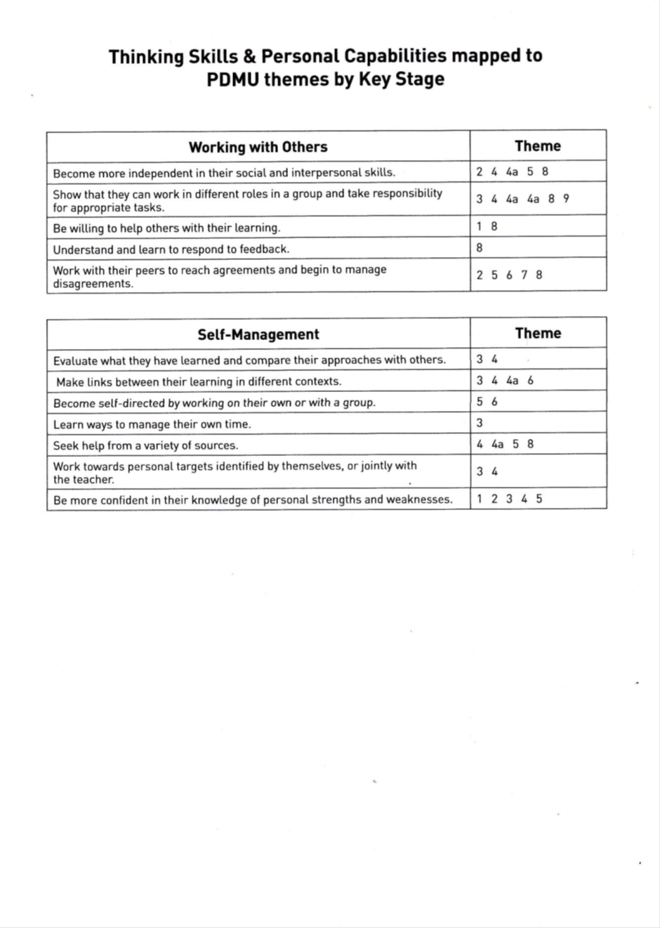

Cross-Curricular Approach

Each area of the curriculum has a contribution to make to PDMU and vice-versa. In St. Oliver Plunkett, teachers employ cross-curricular topics to the mutual benefit of all areas of learning: Language & Literacy; Mathematics & Numeracy; PDMU; The Arts; The World Around Us; Physical Education; Religious Education; and the cross-curricular skills of Communication, Using Mathematics and Using ICT.

Within Northern Ireland Key Stages 1 and 2 three objectives and a series of issues are identified in relation to all areas of learning, including PDMU:
Curriculum for Key Stages 1 and 2 three objectives and a series of issues are identified in relation to all areas of learning, including PDMU

Within the Northern Ireland: To Develop the Young Person as an Individual | To Develop the Young Person as a Contributor to Society | To Develop the Young Person as a Contributor to the Economy and Environment
• personal understanding  • personal health  • mutual understanding  • moral character  • spiritual awareness | • citizenship  • cultural understanding  • media awareness  • ethical awareness | • employability  • economic awareness  • education for sustainable development

