St. Oliver Plunkett P.S.
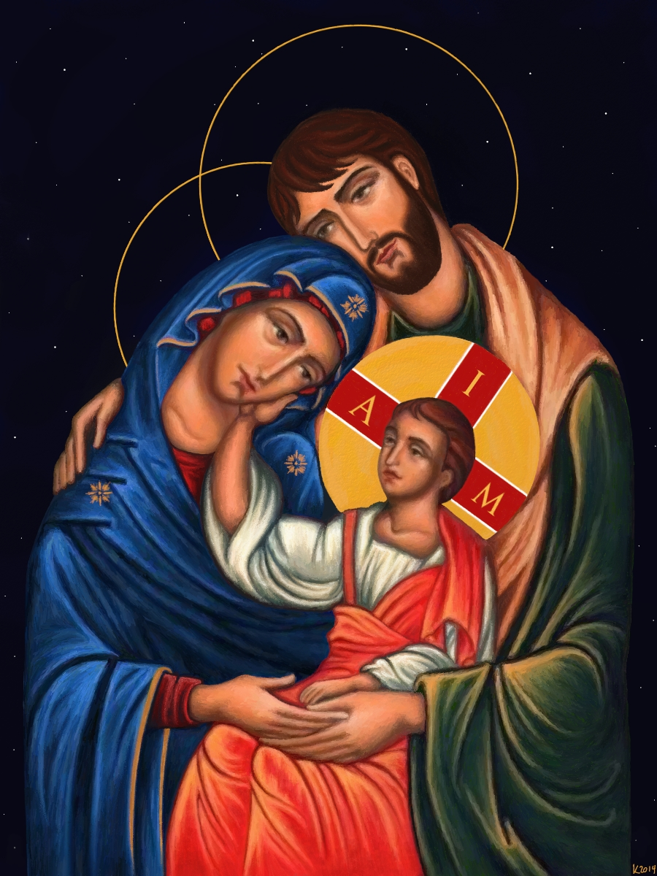

RSE Policy
Date: 15th June 2025
Review Date: 15th June 2027

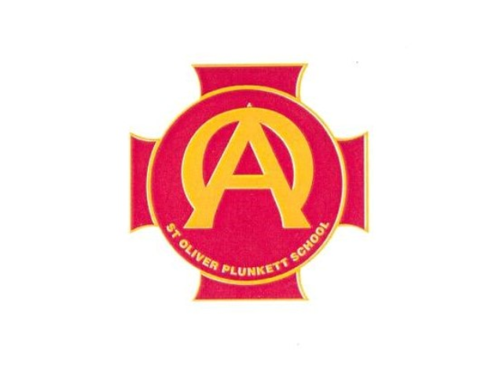
Vision Statement
St. Oliver Plunkett Catholic Primary School, rooted in the community it serves, is a centre of excellence in learning and teaching. It makes a difference to the lives of all children and their families through a holistic approach to education which is nurturing, innovative and creative.
Mission Statement
Our mission is to serve the children, families and wider school community through delivering high quality learning and teaching across, all aspects of the curriculum, for all children, in a nurturing, positive environment.

We have high expectations for children and staff. We build confidence by providing opportunities for daily success and celebrate the achievements of all. Through a collegial approach to effective planning and delivery, we build trust, respect and enable the gifts and talents of children and staff to develop fully.
Rationale
St. Oliver Plunkett P.S. view the development and implementation of a policy in Relationships and Sexuality (RSE) as an important step towards achieving our aim to develop all aspects of a young person’s personality and growth. The morals and values of our Catholic ethos are the core principles that underpin the teaching of RSE. Sexuality includes all aspects of the human person that relate to being male and female and develops throughout life. It is a complex dimension of human life and relationships.
For children, the learning process has begun informally, with their parents or carers, long before any education in a formal setting takes place at school. Sexuality includes all aspects of the human person that relate to being male or female: it may be subject to change, and it develops throughout life. Sexuality is an integral part of the human personality and has biological, cultural, psychological, social, and spiritual dimensions. Effective Relationships and Sexuality Education is essential if children are to value themselves as individuals and are to make responsible and well-informed decisions about their lives.
In line with our school’s ethos, RSE should provide opportunities that enable pupils to:
- Form values and establish behaviour within a moral, spiritual, and social framework consistent with our Catholic ethos
- Learn how to develop and enjoy personal relationships and friendships which are based on responsibility and mutual respect
- Build the foundations for developing more positive personal relationships in later life
- Make positive, responsible choices about themselves and others and the way they live their lives
It is presented as part of the Religious Education programme and the lessons for each year group are linked to corresponding Grow in Love lessons. The policy is also linked to other curricular areas such as PD&MU (Living, Learning Together) and Health Education.

Context
St. Oliver Plunkett PS is a Rights Respecting Catholic school that is Christ centred, we concentrate on the growth potential of the human person, physically, emotionally, socially and spiritually. We are committed to providing our pupils with a positive attitude towards Catholic education. Christ’s values and Gospel message are an intrinsic part of our ethos, daily running of the school and our curriculum. We try to ensure that we work in partnership with the home, parish and the wider community to strengthen our pupils’ vision of their role as part of the Catholic community.
This policy has been written in line with Department of Education N.I. requirements and Catholic Schools’ Trustee Service Relationships and Sexuality Education Guidance Document for Primary Schools: Northern Ireland (NI) 2021.
Teaching Resources
The school currently follows the Grow in Love Programme. It is based on the Catholic Preschool and Primary Religious Education Curriculum for Ireland. This curriculum was approved by the Irish Catholic Bishops’ Conference and was granted recognitio from the Holy See in 2015.
The RSE programme of lessons have been shaped by using the ‘Flourish’ RSE Primary School Programme (CPSMA 2021). Teachers may supplement these approved resources with others but must be satisfied that the resources they plan to use:
• reflect the ethos of the school;
• are age-appropriate, inclusive, and sensitive to the pupils’ needs and experiences;
• are factually accurate and up-to-date; and
• make clear distinctions between fact and opinion.
• do not contain inappropriate / explicit images

Aims of the RSE Policy
- To help the children to appreciate their worth, dignity and uniqueness as children of God.
- To foster and promote their moral development.
- develop a positive sense of self-awareness, self-esteem and self-worth
- begin to develop their own moral thinking and value systems in line with our Catholic Ethos;
- To enable the children to appreciate that sexuality is a gift from God.
- To foster and develop mutual respect and understanding.
- Learn about an appreciation of the dignity, uniqueness and well-being of others and of
friendships, healthy relationships and behaviours with others;
- To develop a respect for difference, gender and race within the school and community.
- To build a system whereby staff members may develop professionally to facilitate the needs of our pupils.
- learn about keeping themselves safe and know what to do or who to go to if they feel unsafe.
- develop an awareness of differing family patterns;
- develop strategies to make decisions, solve problems, and implement actions in various
personal, social and health contexts;
- become aware of the variety of ways in which individuals grow and change and understand
- develop some coping strategies to protect self and others from various forms of abuse;
- acquire and improve skills of communication and social interaction.

Skills Promoted (including personal and social)
Pupils will develop:
• Communication skills - Listening to other’s points of view, putting one’s own
view forward, dealing with conflict peacefully and being assertive.
• Decision making skills - Making good choices with the relevant information at
hand, making moral judgments wisely in contexts and then putting them into
practice, acting responsibly as an individual or as a member of a group.
• Interpersonal skills - Managing healthy relationships with confidence and with
effectiveness.
Definitions
Relationships and sexuality involve the whole person and impact on the physical, spiritual, social, psychological, and cultural aspects of each person. The gift of sexuality shapes relationships through the qualities of love, respect and future new life.
- Sexuality
A gift from God. Our faith leads us to a sense of belonging and identity and of being connected to others, the world and to God.
- Morals
Morality is linked with how we behave and what we do. It is also linked to our values and faith. It is both personal and public.
- Values
These are the characteristics of good moral behaviour, for example, respect for self and others, honesty. (Linked with RRS Ethos)
- Ethics
This refers to a systematic structure, in this case the Christian tradition which involves living a lifestyle with Christian values.

Specific Issues
The foundation for the effective delivery of RSE is the building of secure, trusting, respectful relationships between the teacher and their pupils.
We will ensure RSE is sensitive to the different needs of individual pupils in respect to pupils’ different abilities, levels of maturity and personal circumstances; for example, their own sexual orientation, faith or culture and is taught in a way that does not subject pupils to discrimination. Lessons will also help children to realise the nature and consequences of discrimination, teasing, bullying and aggressive behaviours (including cyber-bullying), use of prejudice-based language and how to respond and ask for help.

It is therefore key that teachers take into consideration the following issues:
- The status of the Family
The relationships within a family are central to the RSE programme, while teachers will remain sensitive to social changes and family make-up of modern society today.
- Sacredness of Life
Life is sacred from the moment of conception and can never be compromised.
- Young people with special educational needs (SEN)
We ensure children with SEN in mainstream schools have appropriate, accessible and relevant Relationships and Sexuality Education. When necessary resources and teaching activities should be adapted of to ensure that there is access to this curriculum.
- Working in mixed and single-gender groups
We teach in a whole class mixed gender classroom environment. P7’s are separated into single-gender groups when exploring puberty related issues during the Diocese’s “What’s Inside?” Programme.
- Confidentiality
The issue of confidentiality should be discussed, and a decision made in line with our school policy on Child Protection. The needs and rights of the child are of paramount importance.
- Homosexuality
The Catholic ethos of the school ensures that gospel values, inclusivity, equality and respect for all and the right of everyone to learn in a safe and secure environment where all are treated with respect and dignity. The ethos of a Catholic school supports the guidance produced by the Equality Commission on eliminating sexual orientation discrimination. This guidance relates to the Equality Act (Sexual Orientation) Regulations (Northern Ireland) 2006 and the guidance from the Equality Commission in March 2009.
Most children will be aware of the language relating to homosexuality. Rather than deliberating on the topic of homosexuality, the use of inappropriate language or related bullying should be dealt with through the school’s behaviour policy.

- Personal backgrounds and cultural practices
Sensitivity to the personal circumstances and cultural background of our pupils is paramount.
- Digital Safety
The RSE Programme will teach pupils how to safely navigate the digital world. Technology plays an integral role in the lives of pupils which poses both opportunities and risks. The RSE Programme will raise awareness of potential threats or dangers posed by the Internet such as sexting, cyber-bullying, pornography, abuse and exploitation. Pupils will explore the implications of the law, the strategies they can use to protect themselves and where they can access advice and support if they are at risk.

Withdrawal
The NI Curriculum Relationships and Sexuality Education Guidance 2015 states that, Whilst Relationships and Sexuality Education is a statutory component of the Northern Ireland Curriculum, parents or carers have a right to have their children educated in accordance with their wishes. Therefore, whilst ‘there is no legislative provision permitting parental withdrawal from sex education’, schools can grant these requests on an individual basis. Schools should consider how they can support parents or carers who choose to withdraw their child from all or part of the Relationships and Sexuality Education programme. This may require the pupil going to another class for the duration of the lesson. The school should take account of parental/carer concerns and treat issues on an individual basis and support and allay concerns. Pupils should be provided with the teaching materials for home use on request and with the proper guidance.

Terminology
It is important that our children are exposed to and taught the proper biological terms in their RSE Programme in the context of:
      - family
      - love
      - respect for self and others

Implementation of the Programme
The programme depends on sensitive delivery of the lessons by class teachers. This includes adapting lessons to meet the needs of children with learning difficulties. It may be appropriate to utilise the expertise of other agencies to ensure the effective delivery of the programme particularly in KS2.

The use of outside Agencies
If personnel from outside agencies are to be invited in, for example a nurse to talk about pubertal changes, their work should complement the RSE programme rather than replace it. The class teacher should be present during any presentation by outside agencies. The activities of outside agencies should be in line with the Catholic ethos of the school. Agency personnel should be vetted to comply with Child Protection policy. Confidentiality should be discussed with them and all resources they intend to introduce should be vetted beforehand.
Parents/carers should be made aware in advance of the use of outside agencies.

Assessment of RSE
The nature of RSE is strongly orientated towards Personal Development which does not necessarily lend itself to summative assessment. RSE is not easily measurable as it is qualitative rather than quantitative.

Monitoring and Evaluating
The RE Co-ordinator should work with the Pastoral Care and PD&MU Co-ordinators and class teachers to monitor and evaluate the programme. There should be feedback from:
      - pupils
      - teachers
      - parents and
      - any outside agencies used

The policy should be reviewed every 2 years.

Staff Training
Staff training will be accessed through the Diocesan Advisers and selected outside agencies. It is essential that all outside visitors/speakers be approved by the Principal/RSE co-ordinator. The school will ensure outside agencies’ teaching is rooted in Catholic principles and practice.
Links to other policies
This policy should not be seen in isolation and should be cross referenced with other school policies:
- Pastoral Care Policy
- Safeguarding and Child Protection Policy
- E-safety Policy
- Anti-Bullying Policy.
- PDMU Policy
- RE Policy

Programme Overview
Year Group | Flourish (2021)
Year 1 | - Myself- I am Me ( FS Th 1 Self Awareness St 1 Themselves and their Attributes)  - Myself- My Body (FS Th 4 Health, Growth and Change: The Importance of Keeping Healthy)  - Myself and Others I Have a Family (FS Th 5 Relationships St 2 Relationships with Family and Friends)  - Myself and the Wider World I Have Friends (FS Th 5 Relationships St 2 Relationships with Family and Friends)
Year 2 | - Myself Growing and Changing (FS Th 4 Health, Growth and Change: The Importance of Keeping Healthy)  - Myself Keeping Safe (FS Th 4A Str 1 How to keep safe in familiar and unfamiliar environments.)  - Myself and Others My family (FS Th 5 Relationships St 2 Relationships with Family and Friends and FS Th 8 Similarities and Differences St 2 similarities and differences)  - Myself and the Wider World I can make choices (FS Th 2: Feelings and Emotions St 1: Their own and others’ feelings and emotions and Th 6 Rules, Rights and Responisibilities Str 2 Their responsibilities for self and  others)
Year 3 | - Myself I am Unique (KS1 Th 1 Self-Awareness St 1 and 2 their self esteem and self confidence)  - Myself My Body (KS1 Th 4 Health, Growth and Change St 1 Strategies and skills for keeping healthy)  - Myself and Others My Family Loves Me (KS1 Th 5 Relationships St 2 Initially mutually satisfying relationships.)  - Myself and the Wider World My Neighbourhood (KS1 Th 8 Similarities and differences St 2 Similarities and differences between people and Th 9 Learning to live as members of the community St 2 themselves as members of a community)
Year 4 | - Myself The Wonder of New Life (KS1 Th 4 Health, Growth and Change St 1 Strategies and skills for keeping healthy)  - Myself We have Feelings (KS1 Th 2 Feelings and Emotions St 1 Their own feelings and emotions and how their actions affect others)  - Myself and Others Friendship and Fairness (KS1 Th 6 Rules, Rights and Responsibilities St 2 Responsibilities, respect, honesty and fairness)  - Myself and the Wider World Decisions and Consequences (KS1 Th 2 Feelings and Emotions St 1 Their own and other’s feelings and emotions and how their actions affect others)
Year 5 | - Myself- Making the Right Choice (KS2 Th 2 Feelings and Emotions St 1 their management of a range of feelings and emotions and the feelings and emotions of others)  - Myself and Others Positive Role Models (KS2 The 5 relationships St 2 initiating and sustaining mutually satisfying relationships)  - Myself and the Wider World Why Have Rules? (KS2 Theme 6 Rules, Rights and Responsibilities Str 2 human rights and social responsibility)
Year 6 | - Myself – Feelings (KS2 Th 2 Feelings and Emotions St 1 their management of a range of feelings and emotions and the feelings and emotions of others)  - Myself and Others Bullying (KS2 Th 1 Self-Awareness St 1 and 2 Their self esteem, self confidence and how they develop as individuals)  - Myself and the Wider World Environmental Care (KS2 Th 9: Learning to live as members of the community St 2 playing an active and meaningful part in the life of the community and be concerned about the wider environment)  - Grow in Love Primary 6 Theme 8 The Church Lesson 4: Working for Christian Unity Teacher Book 310-321 (KS2 Th 8: Similarities and Differences St 2 valuing and celebrating cultural differences and diversity)  - Grow In Love Primary 6 Additional Material Lesson 3 Our Muslim Brothers and Sisters (Intereligious Education) Teacher Book Pg 433-442(KS2 Th 8: Similarities and Differences St 2 valuing and celebrating cultural differences and diversity)
Year 7 | - Myself Emotions and Relationships (KS2 Th 2 Feelings and Emotions St 1 their management of a range of feelings and emotions and the feelings and emotions of others)  - Myself and Others Love (KS2 Th 5 Relationships St 2 initiating and sustaining mutually satisfying relationships)  - Myself and the Wider World Safe Internet (Th 4A Safety St 1 coping safely and efficiently with their environment)  - What’s Inside? Workshop will take place for all P7 students. (KS2 Th 4: Health, Growth and Change: Strand 1 how to sustain their health, growth and well-being.)

*** Theme and Strand from DENI Statutory Minimum Requirements for Relationships and Sexuality Education noted beside each lesson***

