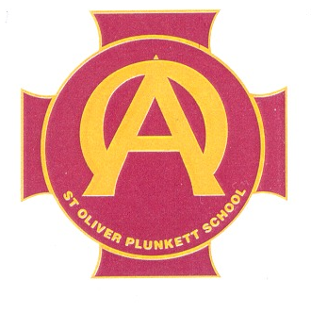

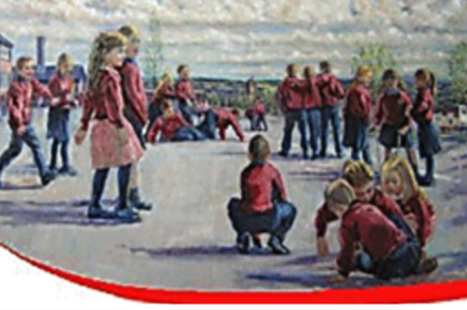

PUPIL VERSION OF SDP 2024/25

If I am worried, who can I talk to?

Mrs. Roche

- Designated Teacher

Mrs. Hanna
Mrs. Diamond
- Deputy Designated Teachers

OUR SCHOOL’S HOPE THIS YEAR, THAT WE…
LITERACY.
- Develop our comprehension skills.
- Develop our ability to listen to and ask questions that allow us to get information that we might need.
- We will get the opportunity to talk with teachers about our learning in Literacy.
NUMERACY.
- Develop our problem solving skills.
- Develop our ability to solve word problems.
- Develop our use of mathematical language.
- We will get the opportunity to talk with teachers about our learning in Numeracy.

OUR SCHOOL’S HOPE THIS YEAR, THAT OUR TEACHERS…
PLAY BASED LEARNING.
- Will observe how we play and how we play with each other.
- Will help us to develop our speech and our vocabulary.
PASTORAL CARE.
- Will work to develop a new Anti-Bullying Policy. They will take on board our views when it is being developed.
- Will work to develop a new Positive Behaviour Policy. They will take on board our views when it is being developed.

