QUICK REFERENCE PARENT VERSION OF THE SCHOOL DEVELOPMENT PLAN Year 2 2024/25.

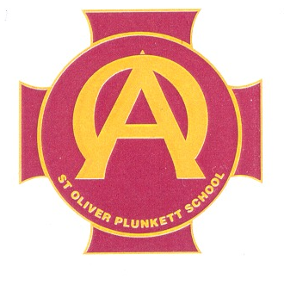
SCHOOL DEVELOPMENT PLAN
2023 – 2026
Mission Statement
Our mission is to serve the children, families and wider school community through delivering high quality learning and teaching across, all aspects of the curriculum, for all children, in a nurturing, positive environment. (UNCRC Article 3)
We have high expectations for children and staff. We build confidence by providing opportunities for daily success and celebrate the achievements of all. Through a collegial approach to effective planning and delivery, we build trust and respect and enable the gifts and talents of children and staff to develop fully. NCRC Article 29)

KEY PRIORITIES.
- School website
www.stoliverplunkettprimary.org

Curriculum Targets
- Literacy
- Development of non-narrative comprehension.
- Development of Inferential Skills.

- Numeracy
- Development of Problem Solving Skills
- Development of Word Problems

- Learning through Play
- Embedding of Play Planners and Resources in FS.
- Development of new Speech and Language assessment package incorporating WellComm and Talk Boost in Foundation Stage.

- Special Educational Needs
- SENCO continues to ensure there is early identification of pupils with specific needs
- New PLP to be developed, reflected upon and embedded taking into consideration pupil and parent voice.

LEADERSHIP & MANAGEMENT
- Data Collection
- Use of internal tests to set targets in Numeracy and Literacy on a Year Band, class and individual pupil basis.
- Development of new Website to more readily identify individual pupils or groups and to ensure pupils are placed in the correct ability groups.

- Pastoral Care
- Pastoral Team to review and develop new Anti Bullying Policy and Positive Behaviour Policy.
- Designated Teacher is Mrs. Roche
- Deputy-Designated Teachers are Mrs. Hanna and Mrs. Diamond
- Deputy-Designated Teacher for C.P. with a focus on E-Safety is Miss McCabe
- Our current Governor for Child Protection is Fr. McAleese.
- New Pastoral Care Team formed.

- Teaching & Learning
- New Learning and Teaching policy devised and ratified by B.O.G. This policy has been added to the school website.
- Curriculum teams in Literacy, Numeracy, ICT and Assessment formed.
- A new Monitoring & Evaluating structure to include Pupil Voice as an integral part.

- Area of the Curriculum Leaders
- Numeracy – Ms. Mohan and Mrs. Hanna
- Literacy – Ms. McNeill and Mrs. Stuart
- SEN – Mrs. Roche
- The World Around Us – Mr. Reid
- ICT – Mrs. McCullagh and Miss McCabe
- Assessment – Mrs. Hanna and Mr. McBride
- Art – Mrs. Kavanagh
- Music – Mr. Flanagan
- PDMU – Mrs. Diamond
- P.E. – Mr. Muldoon
- Religion – Mr. McBride

