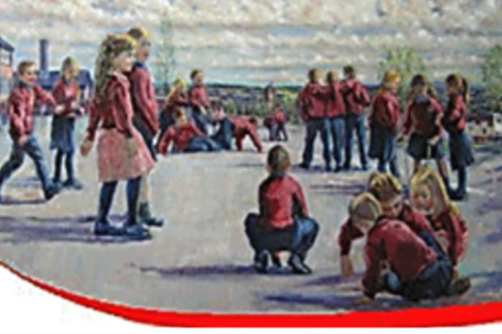

St. Oliver Plunkett Primary School


SCHOOL DEVELOPMENT PLAN 2023-2026

Section One: A statement and evaluation of the ethos of the school
ETHOS STATEMENT

St. Oliver Plunkett was a man of faith; we take inspiration in the man and his qualities.

As a Right’s Respecting School, St. Oliver Plunkett, embraces those attributes which were found in the man himself; characteristics of selfless dedication to those whom we serve, perseverance in that we will strive to overcome any barriers that impact upon our pupils’ health, well-being and academic attainment and courage in that we will constantly strive to become better through reflection on all aspects of our school. (UNCRC Article 24)
We do this by embracing the essence of Saint Oliver; in our school we have:
Openness; in that we are open minded to the views of others, open hearted and open to innovation.
Love; in that we strive to develop a lifelong love of learning, love of others within our school, our community, our country and globally.
Integrity; in that genuine integrity in our relationships with all others, results in a happy school
Vision; in that we have clarity of purpose in all that we do and why we do it; it is for the children in our care.
Enthusiasm; in that we meet challenges with purpose, with a collegiality and with the courage to take risks as learners and teachers
Respect; in that we are respectful of others; be they pupils, members of staff, members of our wider community or global village.
Vision Statement
St. Oliver Plunkett Catholic Primary School, rooted in the community it serves, is a centre of excellence in learning and teaching. It makes a difference to the lives of children and their families through a holistic approach to education which is nurturing, innovative, and creative.
Mission Statement
Our mission is to serve the children, families and wider school community through delivering high quality learning and teaching across, all aspects of the curriculum, for all children, in a nurturing, positive environment. (UNCRC Article 3)
We have high expectations for children and staff. We build confidence by providing opportunities for daily success and celebrate the achievements of all. Through a collegial approach to effective planning and delivery, we build trust and respect and enable the gifts and talents of children and staff to develop fully. (UNCRC Article 29)

SCHOOL AIMS

As a Right’s Respecting School, we aim to provide a safe, happy, stimulating well-ordered community in which the children can learn and be valued as individuals. (UNCRC Article 29) To achieve this, the school will help pupils:

- To secure the highest possible academic attainment for each pupil in our care
- To nurture in each child a knowledge and love of the Catholic faith
- To develop the core Thinking Skills and Personal Capabilities of the NI Curriculum and in doing so develop independent learners and thinkers capable of playing a productive part in society.
- To provide a challenging, rich and balanced curriculum, including experiences beyond the school, which is well planned and effective in meeting the needs of all our children.
- To understand the world in which they live and their role in it, and to give them confidence to proceed to the next stage of their development.
- To develop appropriate relationships with other children and adults, working together in a spirit of co-operation and mutual respect
We very much embrace the use of emerging technologies as a tool to enhance the teaching and learning within our school.
As part of our on-going commitment to ICT and indeed to immersing ourselves in the realities of our children, we have a realistic outlook. The use of technologies and their seamless integration into the learning experiences of the whole school community is predicated on the singular purpose of teaching and learning. It is used to engage, excite and enhance learning to ensure effective teaching and learning.
We are very proud that this methodology has been recognised by the ETI when in their report of May 2015 they stated, “The children’s achievements and standards in ICT are outstanding. In a progressive manner, across all key stages, the children develop excellent skills in using a wide range of ICT devices, programmes and applications confidently and appropriately to enhance their learning.”
This was reinforced further when in January 2016 we were identified as a Digital School of Distinction. Our practices were recognised by Apple when they invited us to complete application for their prestigious Distinguished School program. We are thrilled to say that in November 2016 we were announced as the first primary school on the island of Ireland to receive Apple Distinguished School status. This global standing recognises the work of the whole school using technology to enhance learning outcomes.
It was further gratifying that our use of emerging technologies was recognised in May 2017 when we were asked by ETI to disseminate our good practices over four workshops at the Chief Inspector’s Report launch.

Technologies are an element that requires balance and there is a realisation that we need to ensure our children, staff, parents and indeed wider community are aware of the inherent risks that technologies may bring, when misused.
To this end, we have set up a dynamic e-safety committee, which combines teachers, teaching assistants, pupils and a Governor. Our lead teacher is proactive in disseminating the messages of e-safety and works in close liaison with our Designated Teacher to deal with any issue in a timely fashion.
To capture the imagination of the children within our school, the e-safety committee developed a school e-safety mascot Cyber Tiger, e-safety slogans, e-safety policies, in fact a package of measures which they, and we, hope will ensure that our children are aware of any dangers regarding the use of technologies, in general, and social media, in particular.
We were delighted that this proactive, innovative package received recognition when SWGFL recognised St. Oliver Plunkett Primary School as the first 360 Degree E safety primary school in N. Ireland in February 2016. This was the result of a very rigorous self-assessment followed by an inspection of practices undertaken by SWGFL. This recognition has been maintained since we were first awarded it.
In addition and in recognition of the world in which we, and our children, live we were recognised as a Social School Award recipient.

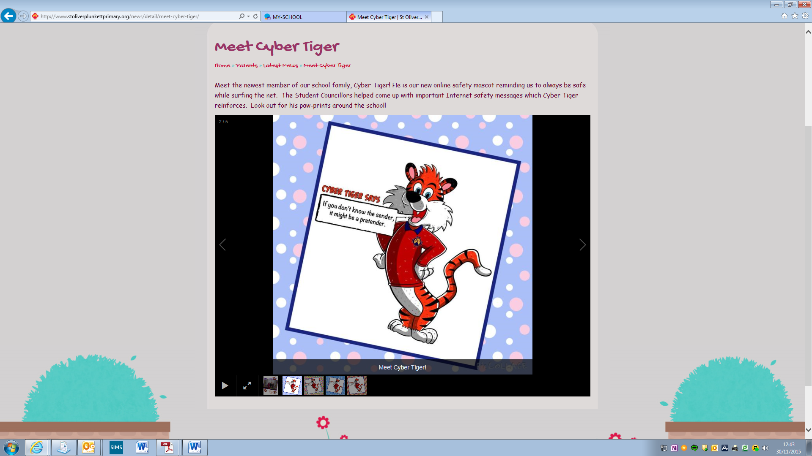

Section One: A statement and evaluation of the ethos of the school
The renewal of our Vision and Mission statements was the result of a lengthy process working with Ms. Gillian McGrath through 2022. Ms. McGrath acted as a critical friend and coach during this process and the result was that the whole school community had input and ownership of the process and outcome.
We are very proud of the developed Right’s Respecting ethos within our school; it is something that is pointed out to us time and again by visitors and parents within our school, we are proud to be St. Oliver Plunkett Primary School. We think the following gives an insight into the reason why our ethos is palpable.
An evaluation of our right’s respecting ethos comprises a wide variety of aspects that make up that spirit they include:
There is a suite of Pastoral Care policies that are in place to ensure the well-being and safety of staff, parents and pupils.
We have explicit and detailed links with external agencies such as Social Services, RISE team, PossAbilities Counselling, Medical Professionals (such as School Nurse, ASD and ADHD Clinics, Speech and Language services etc.) EA Support Services such as Clarawood, Harberton, Oakwood ASD service, St. Gerard’s Outreach, Outreach Peripatetic Services, as well as strong links with Education Welfare, Special and Educational Psychology which are mutually beneficial to child, parents, staff and community.
We show due care and consideration for our staff as professionals and as people that includes:
The fact that we have clear communication with staff, annual calendar issued in advance of the academic year highlighting planning cycles, monitoring cycle etc. Staff are well resourced to ensure they are able to deliver the curriculum.
Communications include regular staff meetings; weekly staff briefings this ensures that all staff are aware of what is ongoing in school as well as expectations.
We have regular fortnightly meetings with classroom assistants.
There are Weekly Low Attainment assistant tutorials with Support Teacher incorporating, recognition, celebration, sharing of good practice and CPD as well as a caring element.
Coordinators and Staff are regularly given release from class to manage the monitoring cycle and integrate the planning cycle.
The above section coloured blue has been significantly impacted upon by Industrial Action and unfortunately none of what was the norm is now ongoing in the academic year 23/24. We are limited to a monthly staff meeting and none of what was an innovative and new Monitoring and Evaluation cycle is currently in place.
This has now been moved forward due to the cessation of Industrial Action and is more reflective of what we had in place.
A review of our Monitoring and Evaluation cycle brought about a new approach. The review took the form of progress interviews with subject coordinators, post holders and Year Band leaders. From those interviews I was able to tease out common threads and it became apparent that we were ready to renew our Monitoring process. The new model includes elements such as Pupil and Colleague Voice, Collegial Book discussions and Trusted Colleague Networks being formally integrated.
Unfortunately, this new model has been impacted upon by Industrial Action.
This has now been moved forward due to the cessation of Industrial Action and is more reflective of what we had in place.
The new SDP cycle will also include a programme of monthly release for curricular leaders, above and beyond monitoring evaluation cycles. It will be as follows on the first Wednesday of each month literacy, the second Wednesday numeracy leaders will be released, the third Wednesday will see ICT//WAU leaders released, the fourth Wednesday will see PE, Music, Art & RE released on a rotational basis.
The purpose of this release will be to review current practices, policies & schemes, planners and evaluations of their specific subjects. It will allow them time to converse with each other about their findings from Collegial Book Discussions, the identification of good practices witnessed in that process and its subsequent dissemination to individual members of staff, year bands, key stage or whole school. This dissemination will form the basis of the Trusted Colleague Network during the next SDP cycle. It will give time to undertake administrative duties, to meet with the Board of Governors Curricular Sub Committee and Principal and to seek out the good practices of other schools, to observe that practice, reflect upon it and adapt it for St. Oliver Plunkett Primary School.
This cycle was put in place and resulted in all curriculum policies across the school being reviewed and sent to Board of Governors for ratification.
Staff are acknowledged and success celebrated via extended breaks and the purchase of treats. They are recognised by the Board of Governors, SLT and peers via formal meetings, dissemination of Good Practice meetings,
Staff to Staff: Monthly SLT meetings, Curricular Meetings, weekly Planning Meetings, Rigorous Monitoring and Evaluation including written feedback, Peer Mentoring including classroom visits, weekly collegial book monitoring.
Unfortunately, this new model has been impacted upon by Industrial Action.
This has now been moved forward due to the cessation of Industrial Action and is more reflective of what we had in place.
We have introduced a new process of Monitoring and Evaluation which incorporates vertical and horizontal monitoring. The Horizontal comes in the form of collegial book discussions (the initial 2016-17 model incorporated ten of these, five literacy and five numeracy; the first two were at a year band level, followed by two key stage level and concluding with a whole school level discussion) The refined model will see six CBDs dispensing with the year band strata and maintaining the rest. The reason being is that it was deemed that the year band level was a duplication of the weekly discussions that take place prior to the planning meetings.
The vertical monitoring comes in the form of a standard book scoop at the beginning of the academic year focussed on clearly identified areas of development from the new SDP and a review book scoop at the end of the process.
PLEASE SEE BELOW A TIMELINE FOR THIS PILOT PROCESS FOR ACADEMIC YEAR 2023-26
YR.1 SDP 2023-2026
BOOK SCOOP
BOOK SCOOP

KEY STAGE CBD
WHOLE SCHOOL CBD
B.o.G C.L. Meetings
B.o.G. Curric Sub. Visit
KEY STAGE CBD

 | OCTOBER | NOVEMBER | JANUARY | MARCH | APRIL | APRIL | MAY
 | BASELINE BOOK SCOOP | KS CBD | B.o.G Visit | KS CBD | B.o.G CL Meetings | WHOLE SCHOOL CBD | REFLECTION BOOK SCOOP
 | LIT//NUM//ICT | LIT//NUM//ICT | LIT//NUM//ICT | LIT//NUM//ICT | LIT//NUM//ICT | LIT//NUM//ICT | LIT//NUM//ICT
This model will be reviewed at the end of the first year and maintained or amended depending upon feedback.
The academic year 2024/25 saw us bring in a new, innovative Monitoring and Evaluation Cycle. It leans heavily on a Collegial Book Discussion at key Stage and then Whole School level that allows for the identification, recognition and sharing of Good Practice across the school. It also incorporates the Pupil Voice at the initial Key Stage session. These layers are reported on by the Coordinators to Principal and via reports to B.o.G. Education Sub Committee.
Staff to Parents: Homework books, Reading Records, Apps such as Seesaw, Parental Workshops in UICT, Communication and ABL in FS. Curriculum Meeting in Term One, Formal Parental Meeting in Term One, Settling in meeting with parents in Yr. One, Facebook, Twitter and School Website are all widely used to engage with parents.
Our use of the SeeSaw app is highly regarded not only by our parent body but by educators across NI.
Leadership to Governors: Regular Board of Governors Meetings, Principal’s Report, Curricular Sub Committee face to face reporting from Curricular Leaders.
Staff induction is in place and has been implemented successfully this academic year. We have a very caring approach to new pupils’ induction; however we are aware that this is informal in nature, in the next cycle of SDP we will formalise and put a policy in place, we have already begun the process through review of our Induction procedures.
Principal operates an open door policy.
All of the above is done to inform staff at all levels, it is our belief that a well-informed staff is a staff that is aware, has ownership and is appreciated.
Our Children are appreciated too through just some of the following. (UNCRC Article 12):
We have a holistic insight into our children that allows us to develop Discussion Groups based on both Underachievement and Low Attainment in Literacy and Numeracy, the children are looked at on an individual basis and their external barriers to learning, if any, are taken into consideration.
Discussions involve the child, parents, teachers both past and present and external services, if appropriate.
Children are then assigned to a short term, initially, package of interventions led by our Support Teacher.
Children are baselined on entry into the programme and re-assessed for continuation or discontinuation purposes.
Data would point to this initiative being highly successful. Parental questionnaires would also highlight a high degree of satisfaction with this initiative.
We have an extensive PDMU programme in place that can be tapped into across the academic year. Initiatives such as RRSA, TREK, Circle Time, The Real Me Academy, Core NI and Art Time, Let’s Shine all play a role in ensuring our children have the capacity for self-development and recognise that they have a role to play in the development and acceptance of others within the local and wider community. In 2023/24 the school began the process of becoming a pilot school for a local initiative developed by St. Patrick’s College, Maghera. Four members of staff will pilot the scheme across the academic year 2024/25.
Our Anti Bullying Programme has been designed in conjunction with our School Council, also includes A Weeklong Focus culminating in our Blue Day and associated Assemblies led by the pupils. Equally we address Online Bullying through our Cyber Tiger initiative, this includes a number of pupil and trained staff assemblies for parents and pupils.
School Council: in the past it has assisted in the creation of a child version of the Anti-Bullying Policy, Online safety, School Yard Buddy system, input into Marking policy and Homework policy, entered into a variety of competitions, met with local representatives at Stormont and invited them in to school.
Pupil Voice: establishing Success Criteria, Plenary feedback, AFL strategies, KWHL grid, taking school assemblies, Class Charters within their own class all ensure that our children play a proactive role in the classroom and their voice is heard in forming the learning experience.
Staff to pupils: Homework, AFL feedback, marking policy including verbal feedback, extensive pupil voice, PDMU Circle Time, Anti Bullying Week, Attendance Challenge, Pastoral Assemblies, Principal’s Awards, Student of the WEEK, new termly Writing and Numeracy Awards, Accelerated Reading recognitions through Word Millionaires, Annual Prize Giving, this list is long but it is not extensive and gives a flavour of the way we acknowledge our pupils as staff.
Our School ethos recognises the children and their efforts pastorally, academically and holistically in both sporting and music fields.
We have a variety of recognitions they include the following: Student of the WEEK, Individual Star Charts, Class Reward systems, Principal Award, Attendance Award, Individual positions of responsibility within the classroom, sharing success with parents, teacher feedback within the classroom both written and verbal, inspiring classrooms with interactive displays that showcase all children’s work, Parent feedback from staff to parent through both formal and informal meetings via our open door policy, recognised in our feedback from parents via questionnaires.
High levels of differentiation built into teachers’ weekly planning, integration of emerging technologies, use of hardware such as Accelerated Reading to enhance reading or Freckle Maths to impact upon numeracy, actively engage with the pupils in the learning process across the planning and implementation of lessons from the KWHL grids, through to negotiated Success Criteria, through plenaries and including Marking for improvement that involves the pupils. We utilise extensively a multi-sensory approach not only in FS but across the school.
Sharing learning outcomes with parents through regularly marked work, through half termly assessments, through the immediate feedback afforded by initiatives such as Accelerated Reading or through the innovative use of apps such as SeeSaw ensures that our parent body are well informed about the learning of their children.
We engage with our parents about their children’s learning so that we can work together to enhance outcomes for our children, including Extended Schools Provision. Again, the use of SeeSaw creates a seamless, immediate flow of information between school and home.
All of the above was confirmed in May 2015 when the ETI inspected our school, this was their finding re: Pastoral Care
“The quality of the pastoral care in the school is outstanding. The school has a well-embedded, inclusive ethos where every child matters; furthermore, the working relationships among the children and between the children and the staff are respectful and caring. The children enjoy an excellent range of extra-curricular activities, which enhance their academic, personal and social development. In discussions with the children, they spoke enthusiastically about a range of school initiatives used to develop their leadership skills and their understanding of personal and civic rights and responsibilities. They spoke positively of how their views on aspects of the life and work of the school are sought and acted on through, for example, their participation in a vibrant School Council and the Eco- Committee.”
ETINI Report of an Inspection May 2015

The reality of our inherent focus on the pastoral care of all of our school community was further recognised when on May 4th, 2016, the school was recognised by UNICEF as a Level One Rights Respecting Award recipient.
It is further reflected in the fact that the ETI visited us as part of their evidence gathering process that lead to the publication of “The Preventative Curriculum in Schools and Education Other Than at School (EOTAS) Centres” as part of its thematic evaluation of the Preventative Curriculum. A number of our practices are recognisable in the document. As part of the visit the Inspector took our overview of the Preventative Curriculum in action in St. Oliver Plunkett.
Furthermore, our ethos was recognised and celebrated in November 2023 when we were recognised as the Pearson Education, UK Primary School of the Year for Making a Difference.

Section 2 A summary and evaluation, including through the use of performance and other data, of the school’s strategies for-
- Learning, teaching, assessment, and the raising of standards of attainment among all pupils, in particular in communication, using mathematics and using Information and Communication Technologies (ICT).
The attainment of our children, given the reality of the high levels of socio-economic deprivation reflected in the percentage of children entitled to Free Schools Meals 65%+ and the associated difficulties that can have on the educational aspirations of a community, is measurably outstanding.
We have also taken the decision to use this School Development Plan as an opportunity to initiate a re-set.
This re-set will take into consideration the realities that the Covid Pandemic and its associated lockdowns have had, not only on attainment but on social development of children as well as the irrefutable impact on their mental health and wellbeing, their parents and the community as whole.
The re-set does not in any way reduce our aspirations for our children, it is simply a recognition that the reality in 2023/24 is different from that of 2019/20. It will mean different priorities, different resource allocations etc.
It is also a recognition that our educational outlook must be tempered by the facts of an ever-increasing SEN register. The SEN register is populated with children with ever increasingly recognised complex needs. A few quick illustrations of such are in the academic year 2011/12 this school had 11 classroom assistants in place today, 2023/24, we have 47.
The SEN register in October 2021 (21/22 academic year) was 112, the register of December 2023 was 168.
It is imperative that the heavy emphasis on a school’s unique context recognised in the Analysis of responses to the Education and Training Inspectorate’s consultation on the development of inspection (Draft 2023) be equally recognised by all stakeholders of our school without in anyway diminishing our aspirations for our children.

Literacy Attainment Baseline 2023/24

Foundation Stage performance falls into the following three categories; Below Average 34% as opposed to the National Expected of 23%, Average 56% in comparison with the National Expected of 54% and Above Average performance was noted as being 11% in contrast to the National Expected of 23%.
We have historically seen figures like these and indeed they have formed the baseline for future Target setting.

The above Key Stage One profile indicates the impact of prior learning in F.S. combined with that of the Key Stage one staff.
Key Stage 1 performance falls into the following three categories; Below Average 30% as opposed to the National Expected of 23%, Average 52% in comparison with the National Expected of 54% and Above Average performance was noted as being 18% in contrast to the National Expected of 23%.

Key Stage Two profiles historically have shown whole school impact and again it can be seen in this outline.
Key Stage 2 performance falls into the following three categories; Below Average 22% as opposed to the National Expected of 23%, Average 57% in comparison with the National Expected of 54% and Above Average performance was noted as being 20% in contrast to the National Expected of 23%.
Across the school the improvements are noteworthy, a reduction from 34% in F.S. to 22% in the Below Average category and an improvement from 11% to 20% in pupils in the Above Average sector.
We are very much aware that this is not year band improvements that are longitudinal rather they are a snapshot of performance in June 2023 across the school. We do include Longitudinal studies later in this SDP as an illustration but again to stress this year is the baseline post-Covid.
We do believe that the above highlights the ongoing cumulative effect of teaching across the school, building success upon the blocks laid in the previous years.

The graph above is an insight into the impact that we as a school community have on our children’s academic performance.
This is the performance of Key Stage Two children in the academic year 2022/23.
Aptitude expectation based on CAT Verbal data would indicate 21% of children falling into the Below Average sector yet performance as measured by PTE is 22%.
It can be clearly seen that the PTE attainment is outperforming the measured CAT Verbal aptitude scores. 20% of the Key Stage are in the above average stanines (7-9) as opposed to 14% having registered CAT Verbal scores in the same stanines.

The high performance of Key Stage Two pupils in literacy is further illustrated when the National Expected percentages are added.

*PTE % appearing as 99% as opposed to 100% due to rounding.
For those children in the Below Average Stanines the National Expected is 23%. Our Aptitude scores show 21% of our children in these stanines and our PTE scores show 22% of our children are attaining in line with the National Expected. Taking into consideration the school context that is a favourable Baseline upon which to build.
The measurable results of those children in the Above Average Stanines are very impressive indeed. The CAT verbal scores would indicate that we should have 14% of pupils within that sector yet our attainment has 20% of pupils placed in the Above Average grouping. We will strive to move towards the 23% National Expected. The outperformance percentage of 6% is testament to the staff impact in spite of contextual challenges.
Whilst this is to be applauded, we still strive to widen those positive performance gaps, identified above, through analysis, target setting, strategies employed in school, TPL etc.
One of the primary focuses of this SDP cycle will be to home in on those pupils in Stanines Three and Four, they are a combined 30% and we want to try to ensure no slip into the Below Average grouping and to try positively migrate pupils in those Stanines.

The graph above shows the performance of those children deemed Low Attaining because they had a measurable IQ of less than 86. As can be seen we had 11% of Low Attaining pupils Underachieving (-10 or more). There are a combination of reasons that could be offered up at this point; it is reflective of post Covid disengagement, poor attendance trends, SEN needs that in the past may have warranted Specialist provision or schools etc. However, we recognise this as a target and will endeavour to reduce this number over the lifespan of this SDP.
As can be clearly seen from the Bar Chart above, of those children deemed to be Low Attaining (i.e. with an IQ of 85 or below) 32% of those deemed Low Attaining are scoring above their noted IQ, as opposed to 11% scoring below IQ with 57% scoring commensurate to their IQ.
The comparison when looking at the last SDP is striking. At the beginning of that cycle we had 47 pupils identified as Low Attaining, at the end of the three years that had increased to 63. This increase is telling and may well give weight to our assertion about the number of children presenting in school with more complex needs.
Consequently, a larger attainment gap will start to appear. However, we must also be cognisant of the growing adverse personal and community experiences of the children within the school, considering the social impact of prolonged COVID lockdowns and the inevitable austerity measures on the post-COVID economy and public resources.

The above graphs show those pupils who were considered as having Aptitudes measured at 86 and above. You can see that we have approximately 85% of pupils in this grouping believed to be in the Average to Above Average performance categories.
We aim to reduce the 15.28% with a greater focus on the pupils transitioning from Year 6 into Year 7 the academic year, 2024/25. All teachers currently identify and target specific underachieving children using standardised scores and CAT scores. These children form a particular focus for the class teacher over the course of the academic year and all targets are reviewed at the end of each academic year. It should also be highlighted that, as a school, we are trying to highlight children underachieving in stanines 3 and 4 for those children who are on the cusp of below average/average and children currently occupying 6 who are on the cusp of moving into above average attainment. It is important to note that several children in the aforementioned 15.8% achieved elevated CAT scores of 120 or more. Their attainment scores, whilst exceeding that expected for their age, still fall into the category of underachieving due to their CAT’s. Whilst we as a school, are aware of this situation, we do not feel these children should be specifically targeted as underachievers for two reasons. Firstly they are still achieving levels well above average and the greater and their teachers can address the shortcomings in class targeting and planning and secondly because there is greater need to positive migrate/ maintenance of students within stanines 3/4/6.
The reason I have used this insight is to illustrate the actions taken upon identification of an issue or need in our performance data.

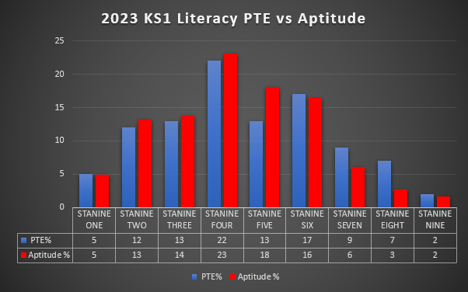
Again, the pattern of performance that was seen in the KS 2 Literacy comparative performance is continued in KS 1.
We have 11% of children with Aptitude scores in the Above Average Stanines, however we have 18% of the KS are performing in those Stanines, a positive of 7% above the comparative expected.
In the Below Average Stanines there are 32% of pupils with measured Aptitude standardised scores and 30% are in that same range when measuring performance.
I would again state that this is a clear indication of the impact of the Pandemic on not only educational performance but also engagement.
It is again a clear insight into the necessity to use this SDP as a re-set Baseline.
We would like to point out that the Aptitude scores are a combination of NRIT in Year Three and CAT Verbal in Year Four.

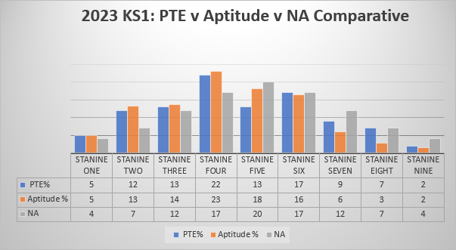
The Data Table, in the above graph, shows the positive impact on the outcomes of our teaching and learning of the myriad of new strategies, initiatives and resources that we have introduced as a school since the inception of the last SDP.
Below Average Aptitude scores are at 32%, performance is at 30%, the National Expected norm is 23%. We will strive over the course of the next SDP to come in line with the National Expected in this category.
The Average Stanines show aptitude (Aptitude combined scores) at 57%, attainment (PTE) at 52% and the National Expected at 54%.
The Above Average Stanines show that aptitude was at 11%, performance at 18% and the National Expected at 23%.

This is a notable positive. Those children with a measured aptitude score of 85 or less are deemed to be Low Attaining and it’s clear to see that early intervention measures such as our Harberton Reading programme in Year Two and IEN interventions in KS1 have made a significant impact.
There are no children deemed to be Underachieving within this subset and equally impressive is the fact that we have 47% of those children measured as High performing, i.e. with Standardised Scores of 10 or more points above their aptitude.
Again, I would have to say that given the impact of Covid and particularly on the cohorts of children who were either pre-school at the time or indeed were too young to access that provision this performance is all the more noteworthy.

Approximately 82% of those KS1 pupils deemed to be Underachieving in Literacy fell into either Average or Above Average Attainment.
An obvious focus will be on those 18% who were noted as Underachieving.

Literacy Longitudinal Study
 | P1 | P2 | P3 | P4 | P5 | P6 | P7
P1 | 94.28
P2 | 86.72 | 102.53
P3 |  | 103.15 | 102.18
P4 |  | 104.05 | 102 | 103.04
P5 |  | 88.02 | 93.32 | 99.29 | 109.27
P6 |  |  | 90.62 | 102 | 99.87 | 96.34
P7 |  |  |  | 99.78 | 104.96 | 101.2 | 103.32

I have included the above Longitudinal Study for illustration purposes. It shows the performance path of each of the Year Bands in our school at June 2017. It tracks the performance of the Year Band as a whole, for example the Year Seven Band started with a Standardised Mean Score of 99.78, that improved to 103.32. Whilst that improvement measures at 3.54 standardised points over the course of four years and may look insignificant, anyone with an insight into these tests and data will know that is a very strong performance line with clear evidence of positive migration on average in each year band.
As part of our re-set, I have detailed the mean data scores per year band below.
It will form the baseline for a similar longitudinal study as showcased above with the intention of showing a similarly strong performance line at the conclusion of this development plan.
 | P1 | P2 | P3 | P4 | P5 | P6 | P7
Baseline;  June 23 Average PTE | 88.48 | 99.73 | 95.62 | 98.82 | 99.24 | 98.25 | 99.57

All that is stated regarding the outcomes of our KS2 children is further reinforced when we take into consideration the comparative with CAT Quantitative scores.
It is this aspect which highlights the need to target improvement more so than the simple attainment profile.
We have 16% of pupils measured in the Below Average grouping for Aptitude yet 27% in this section per their attainment, this is a gap of 11% and we need to reduce it.
Equally so 22% of pupils were measured in the Above Average category as per their aptitude yet we have 19% attaining in those Stanines. Whilst this is a gap of only 3%, we would like to see performance outperforming expected by the end of this cycle.
The above table with a reference to our starting point gives an indication as to our future direction and targets for improvement.
The easily identified target is the reduction of those children in the Below Average Stanines; currently 27% to come into line with the National Expected of 23% and to be more reflective of the 16% of children whose aptitude scores in that same band.
Additionally, we will endeavour to keep growing those children in the Above Average Stanines. At the beginning of the cycle there were 19% in that grouping, we want it to move closer to the 23%.
It should be noted that whilst I am highlighting what I deem to be an easily identifiable target due to analysis of data and its comparative the profile of performance is not that different from the end of the last SDP cycle which was noted as significantly improving over the course of its full cycle.
For example, Below Average then was measured at 24% as opposed to the current baseline of 28% and the Above Average was then 18% and has maintained so.

The graph above shows the performance of those children deemed Low Attaining due to the fact that they had a measurable IQ of less than 85. As can be seen 15.38% are Underachieving (-10 or more). 57.69% are deemed to have performance that is Neutral (-9 to +9) whilst 26.92% have Positive (+10 or more) when compared to their CAT Quantitative scores.
The performance of those measured as above expected scores has improved from the last full SDP cycle as at that point 18.18% were overperforming and now we have a baseline of 26.92%.

The above graph shows those pupils who are Underachieving in comparison with those who are Overachieving. That is those children who are scoring 10 or more points above or below their measured IQ and who have IQs measured at 85 standardised points or more.
There is a notably high percentage (35.5%) of children who are 10% points are more behind their measured IQ. This is another point of required reflection as it has increased considerably since the last SDP cycle moving form 18.3% to this new mark of 35.5%.
Again, it is important to note that all class teachers have a number of underachievers identified using standardised testing vs aptitude criteria at the beginning of each academic year for bespoke target setting. Like the literacy data, we believe it is important to prioritise those students in Stanine 3 and 4 on the cusp of positive migrating into the average stanines/ negative migrating into below average stanines. To further emphasise this point, of the 92 children in KS2 who achieved scores placed within stanines 3 and 4, 49 of them have negative discrepancies of 10 or more. As in literacy, we believe these children are our priority in terms of targeted intervention at class level.

The 2023 chart above references the attainment of Year three & four, the CAT is solely Year Four.
As such there is no true comparative to be made.

Whilst it is true to say that it is difficult to make a comparative between performance and aptitude as performance is for all of KS1, yet the CAT Quantitative performance is relevant only to Year Four, we can still look at the overall performance against the National Expected.
With that in mind, Below Average attainment is exactly in line with the National Expected, we will endeavour to outperform that baseline as we move through this SDP cycle. Additionally, the 13% of pupils attaining in the Above Average section is 10% points below National Expected and is the obvious target area. Furthermore, a cursory glance at the profile shows that 46% of children in Stanines Five and Six, this is a good platform for investigation. The intention would be that a number of those targeted pupils would positively migrate into the Above Average classification.

The above Low Attainers profile shows a combined 87.5% of pupils are performing at or above their expected level with a very healthy 37.5% deemed to be high attaining given their Low Attaining profile. 12.5% are recognised as Underperforming.

Approximately 80% of Year Four children who are deemed to be underperforming when comparing their attainment versus aptitude scores are scoring in line with or above the expected. We note that this means that just over 20% are underperforming and this needs to be monitored moving forward.

The next graphs are a new comparative insight into performance that we have introduced for this SDP cycle. It is further evidence that as well as being wholly transparent, we are trying to gain as great an insight into our performance as a school as we possibly can so that it may aid our improvement agenda.

The above shows solid improvement in those in the Below Average category moving from 30% in 2022 to 25% in 2023 only 2% points from the National Expected. We will endeavour to move those in the Above Average sector from 16% towards 20% as a target over the course of the SDP.

Again, the data shows improvement already in that we have moved from 30% in the Below Average attainment stanines in 2022 to 27% in 2023 and again we have consistency in those in the Above Average grouping as it sat steady at 18%.
PASS Data Insight 2023
This is a new layer of insight that we are introducing in this SDP. It is hoped that we will gain further levels of understanding that may allow us to more effectively target pupils moving forward in all categories to try and identify common threads that underlie under performance or indeed over achievement.
The results of the first chart were a bit of a surprise. The assumption was that the girls would have had a much more favourable outlook than the boys. In fact, there is no huge distinguishing differences, the only ones of note are a 5% gap in Feelings about School and a 6% difference regarding Attitudes to Attendance. The very positive note is that all aspects considered show very high levels of favourability.

Numeracy Longitudinal Study (2017)
 | P1 | P2 | P3 | P4 | P5 | P6 | P7
P1 | 100.58
P2 | 89.87 | 103.38
P3 |  | 102.96 | 104.17
P4 |  | 104.65 | 106.86 | 103.12
P5 |  | 96.66 | 90.68 | 97.1 | 101.49
P6 |  |  | 87.59 | 96.6 | 94.44 | 97.34
P7 |  |  |  | 92.36 | 101.21 | 93.76 | 98.43

The above longitudinal study from the previous SDP (2017) shows the positive impact of numeracy interventions and strategies which were put in place to improve overall standards. These included but were not limited to: a greater focus and emphasis on practical mathematics, a focus on mental mathematics that has seen a new scheme (New Wave Mental Maths) being introduced to the school, a new RUCSAC strategy being implemented across the school, Pitch and Expectation being embedded from Year Three upwards, the introduction of the NHM scheme.
Whilst these strategies are still embedded within the pedagogy across the school, the below baseline does once again highlight the negative impact of COVID and the consequential social and societal issues that accompanied it.

 | P1 | P2 | P3 | P4 | P5 | P6 | P7
Baseline;  June 23 Average PTM | 96.24 | 101.72 | 97.87 | 98.13 | 95.91 | 97.76 | 97.05

Section 2 A summary and evaluation, including through the use of performance and other data, of the school’s strategies for-
- Learning, teaching, assessment, and the raising of standards of attainment among all pupils, in particular in communication, using mathematics and using Information and Communication Technologies (ICT);
Below are the comparisons between the last KS2 cohort unaffected from COVID (June 2019) and our new baseline.)
NUMERACY | STANINES | KS2 2019 | New Baseline | KS2 2019 | New Baseline
<74 | 1 | 3% | 6%
74-81 | 2 | 9% | 8%
82-88 | 3 | 10% | 14% | 22% | 28%
89-96 | 4 | 20% | 20%
97-103 | 5 | 15% | 18%
104-111 | 6 | 21% | 16% | 56% | 54%
112-118 | 7 | 13% | 9%
119-126 | 8 | 6% | 6%
>126 | 9 | 3% | 3% | 22% | 18%

LITERACY | STANINES | KS2 2019 | New Baseline | KS2 2019 | New Baseline
<74 | 1 | 2% | 4%
74-81 | 2 | 6% | 9%
82-88 | 3 | 13% | 9% | 21% | 20%
89-96 | 4 | 15% | 21%
97-103 | 5 | 19% | 21%
104-111 | 6 | 21% | 15% | 55% | 57%
112-118 | 7 | 14% | 12%
119-126 | 8 | 7% | 4%
>126 | 9 | 2% | 4% | 23% | 20%

Section 2 A summary and evaluation, including through the use of performance and other data, of the school’s strategies for-
(b) Providing for the special, additional or other individual educational needs of pupils.
“1.13 Underachievement is used to describe a situation where performance is below what is expected based on ability. It can apply at the level of an individual pupil or describe a class or school, or indeed a system.
1.14 Teachers are able to use their professional judgement to assess if a pupil is underachieving. This can include classroom observation and analysis of formative assessment or other data as appropriate.
1.15 Low achievement is different from underachievement. Low achievement is where a pupil is achieving to the full extent of her or his ability, but is well below average compared to her or his peers.”

Count, read: succeed – A Strategy to Improve Outcomes in Literacy and Numeracy. DENI. 2011

In conjunction with the above definition, from, “Count, Read, Succeed” and in line with the inclusive ethos of our school, we have tailored aspects of our School Development Plan to meet the needs of those children whom we have identified as Low Attaining or Underachieving.
We developed what was then a new model of identification and delivery for our school at the outset of our last SDP. This IEN (Identified Educational Need) package was initially derived from an analysis of objective data.
The IEN provision has been greatly impacted upon by the financial reality that we now find ourselves in. At the outset of this initiative the IEN team comprised five members of the teaching staff, one full time and four on temporary variations of contract. All of that team have either retired or been subsumed into other positions in the school, i.e. class teachers or Nurture Leader.
The team is now comprised of the IEN Coordinator overseeing the programme, one teacher putting in literacy support for Years Three and Four and a cohort of Teaching Assistants putting in support in Year Two. We will add a Year Five cohort in 2024-25.
Irrespective of the changing reality it continues to be our aim that we will positively impact upon our Data profile through a thorough analysis of data, through target setting on a school, key stage, year group, class level as well as identifying Individual pupils who are deemed to be Underachieving or indeed Low Attaining.
Underachieving pupils are those with an IQ of 85 and above, research would suggest that this is the minimum cut off for IQ deemed to be Average. They are subsequently, deemed Underachieving if their Progress Test English or Progress Test Maths scores are measured at Negative ten points below their IQ.
Over the course of the last SDPs our staff have become much more comfortable with the analysis of multiple data streams from a variety of standardised tests. They use this knowledge to develop a clear picture of the noted areas of strength and development of individual children as observed on those tests. In the past this would have been the singular reason for a child being deemed underachieving; however, the model is now much more sophisticated. There is a greater emphasis on the data being the initial stage, followed by a professional dialogue between the incoming and previous teacher to ascertain whether a child is deemed Underachieving. The data in essence forms a discussion group, the decision for listing a pupil as Underachieving falls in to the hands of the class teacher in conjunction with the previous class teacher, IEN Team and Principal.
Once identified and registered as Underachieving; the class teacher will target the specific areas, put strategies in place and monitor the impact of those strategies on measurable targets.
Our IEN team consisted of five members of the teaching staff, Miss Taggart (SEN CPD targeted and assisted Primary Three and Four pupils deemed Underachieving in Literacy as well as additional children deemed worthy of investigation and support for SpLd Dyslexia up to Primary Seven), Mrs. Diamond, Ms. Connolly and Ms. Mohan (on Permanent Variation of contracts, three days per week; identified and supported primary three to seven pupils identified as Underachieving in Numeracy), Ms. Malone (on Permanent Variation of contract, identified and supported primary five and seven pupils identified as Underachieving in Literacy).
As stated earlier this model has unfortunately fallen victim to the financial pressures that schools find themselves in.
A programme that showed significant impact has therefore been diluted to a point that it no longer represents its original format or purpose.
To meet the needs of those identified as Low Attaining pupils, i.e. those with an IQ of below 85 and Progress Test English or Progress Maths scores in the first or second stanines and whose teacher’s subjective judgement would corroborate them as being Low Attaining, additional support from our classroom assistance group will be put in place.
There is a small cohort of Assistants who are overseen and upskilled by Miss Taggart working across year Two as an early intervention strategy. They implement a forty-minute literacy programme three times per week. The programme is based upon Miss Taggart’s training in the SEN CPD course. Assistants complete daily notes and review the progress of children on a weekly basis with Miss Taggart.
Staff TPL has been targeted towards impacting upon Numeracy too. Several members of staff are recognised by the developers of Izak 9 as SuperUsers, therefore they train other schools in the use of the resource as well as our own. We have a classroom assistant who is trained in Maths Recovery, her programme has been invaluable in enhancing outcomes for the children identified.
We continue to seek out the good practice of others and have availed of TPL from a colleague in a neighbouring school with all teaching staff to enhance pupil recall of the four functions.

We have added several community layers on to our project: primarily through the West Belfast Partnership Board. This includes clustering with schools from across West Belfast to allow Coordinators to come together and share good practice.
Additionally, the West Belfast Partnership Board have supplied us with licences and training in the use of the Accelerated Maths//Freckle programme for our pupils in Years Three to Seven since the academic year 2014-15 and continue to do so.
This programme perfectly supplements our use of the Accelerated Reading programme which we have had in place for the last ten years.
As well as the internal supports for our pupils identified as Low Attaining and Underachieving and in line with the current Code of Practice we do our utmost to identify any and all pupils with SEN.
Our procedures ensure that we liaise with all external agencies that interact with our identified pupils.
The internal supports for our children are further enhanced with external agency supports.

Section 2 A summary and evaluation, including through the use of performance and other data, of the school’s strategies for-
(b) Providing for the special, additional or other individual educational needs of pupils;
One statistic that jumped out when SEN provision was analysed particularly since the Covid lockdowns is the increasing number of children who are being recognised as having SEN.
To illustrate this point I have drawn up the following:
 | 21/22 | 22/23 | 23/24 | 24/25
Percentage of pupils on SEN register | 17% | 26% | 26% | 29%
Pupils with Cognition and Learning as a primary need. | 47 | 71 | 58 | 51
Pupils with Social, Behavioural and Emotional Well-being as a primary need. | 39 | 59 | 57 | 59
Pupils with Speech, Language and Communication as a primary need. | 23 | 32 | 46 | 60

It must be noted that whilst the pupils with these primary needs continues to grow our school size has shrunk over the above timeframe. In real terms this means much higher numbers of children with complex needs in each class.
I am not a sociologist but as an educationalist and given the timeframe above I would argue that the impact of Covid on a cohort of children has not been confined to only those children who were deprived of early pre-school and primary school experiences but to any child who was born and started their lives in that 2020 to 2022 timespan.
This assertion can be supported by the fact that we had 20 Foundation Stage pupils on the SEN register at the beginning of the academic year 21/22 at the end of that year there were 30. At the beginning of the academic year 23/24 there were 28 and 24/25 there are 41. 41 pupils, the majority of whom have SBEW or Speech, Language and Communication as a primary need, not Cognition and Learning.
It is my belief that the increase in figures reflects the reality of socio-economic factors, Covid 19 impact and whilst they may deemed to be negative factors they are to a great extent offset by the staff practices in our school. The staff are proactive at recognising the SEN of pupils and are dedicated to meeting the needs of pupils. They are supportive of parents and pupils alike.
Whilst that is a marked increase it is still below the Belfast EA average. It is my assertion that the increase is a combination of a number of factors; staff are more willing to use the Code of Practice earlier than previously to put in place internal, and if needs be external, supports. It also allows conversations to take place with parents at an earlier stage. One of the other factors that needs to be recognised is the environmental impact on our school’s intake; it is not hypothetical it is quite real.
The reason that it is not higher is equally quite real; it is the dedication, hard work and selflessness of the whole staff team.
In short the recognition of the Pearson Education Primary School of the Year for Making A Difference 2022/23 was a confirmation of the work undertaken across the school community for all of our pupils.
It is also down to the extensive knowledge of the SENCo, her developed partnerships with a plethora of outside agencies and being able to avail of those in-school supports at an early age.
Another layer is that we as a school recognise our reality and that socio economic actuality can often mean that children upon transition into Year one present with speech and language type difficulties. That is why we have developed a new Foundation Stage model utilising the GL WellComm package and combining it with Talk Boost, meaning they can deliver a programme of interventions at the onset to a child’s education, with the aim being to alleviate those issues.
Finally, it is the mind-set that we promote. It is the idea of knowing our children thoroughly, giving them time to settle in, where we can meet their needs within the classroom setting through highly differentiated teaching that shows the child is challenged and progressing, we do not see the need to place a child on the SEN register simply for the sake of doing it.
It is our hope that this already, excellent platform will allow us to further develop our provision to meet the needs of those children we identify with barriers to their learning.

Section 2 A summary and evaluation, including through the use of performance and other data, of the school’s strategies for-
- Promoting the health and well-being, child protection, attendance, good behaviour and discipline of pupils;
http://www.stoliverplunkettprimary.org/key-information/
The above link provides policies for Healthy Eating, Discipline and Attendance.
The school liaises very closely with our colleagues in the School Dinner Services to ensure all of our pupils are offered a healthy
CHILD PROTECTION
The Designated Teachers for Child Protection have been fully trained by the EA. The children and parents are aware of these teachers and the role they play in our school. There are displays of the Designated and Deputy Designated Teachers displayed prominently throughout our school. All staff, teaching and non-teaching, receive Annual child protection refresher training from the Designated Teacher. Equally so, all members of the public who come into our school via Extended Schools are also put through our Child Protection procedures by the Designated Teacher. (UNCRC Article 19.)
The Principal, Designated Teacher and both Deputy Designated Teachers undertook enhanced Operation Encompass training. Operation Encompass its aims and procedures were subsequently rolled out to all staff and Governors. In addition to the traditional Designated Teacher Role for Child Protection and as a result of the reality within which we exist we also created a Designated Teacher for E-Safety. Operation Encompass training was rolled out to all teaching staff.
ATTENDANCE
To establish good Attendance, we will continue to review our Attendance Policy and practices. We will communicate effectively with our parent body to ensure they are aware of the link between attendance and pupil attainment. (UNCRC Article 28)
We will establish a monthly profile of all classes’ attendance in comparison with their Year Group peers. We will celebrate whole class attendance on a monthly basis, as well as recognising individual pupil attendance through the 100% Attendance Awards at the end of the Academic Year.
We will liaise closely with our colleagues in the Education Welfare Service to tackle consistently poor attendance that has not improved through in-school interventions.
The school attendance target for the academic year 2022 to 2023 was 89.4%. Pre-Covid our Average attendance set at 95%.
We will continue to work hard at getting the message out to parents and guardians that attendance is vitally important. We will continue to work closely with statutory bodies such as the Education Welfare Service to impact positively upon our attendance. We will continue to proactively promote the message that attendance is important to the outcomes of our children to our parent body.
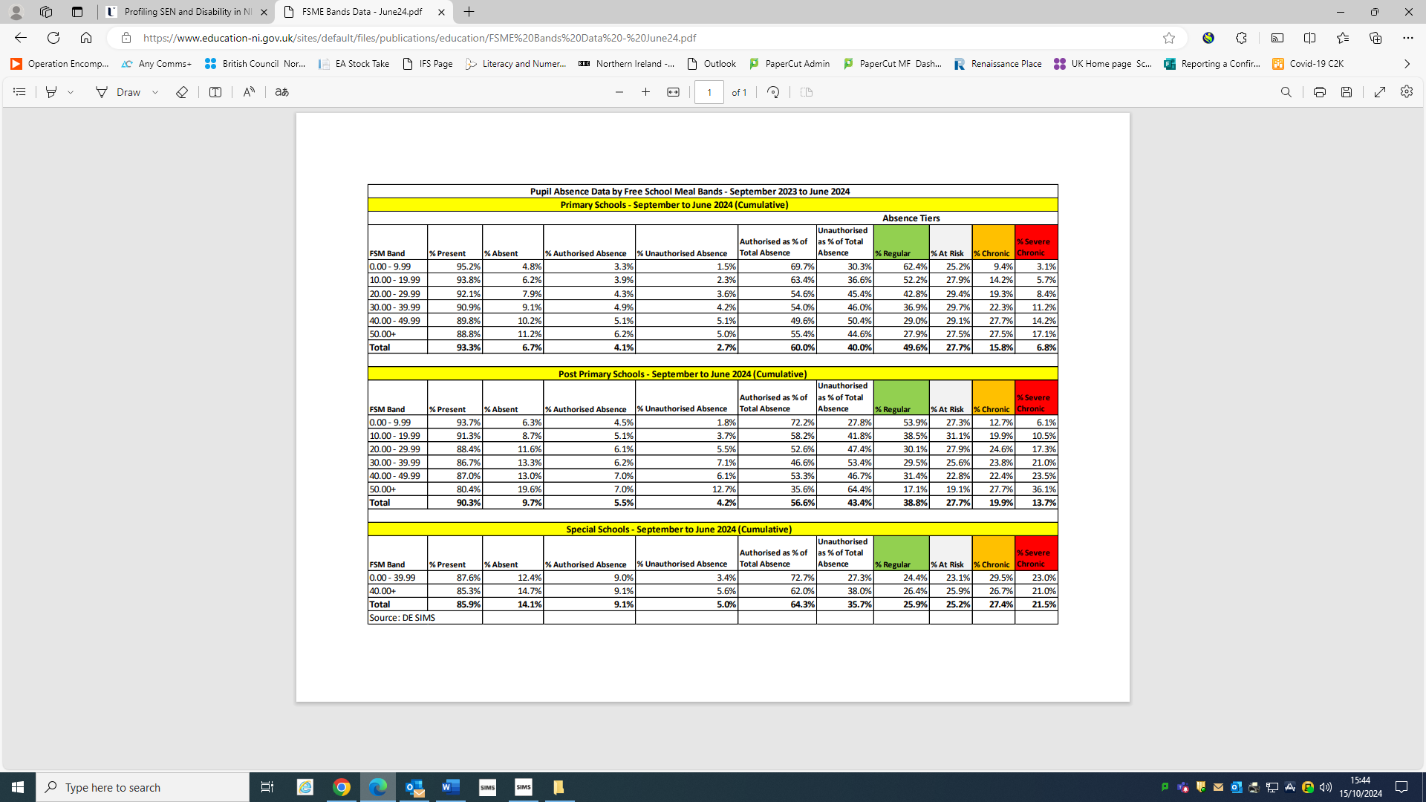
The above Chart issued by DENI shows that in comparison to those schools in the 50+% bracket where the average attendance for the Academic Year 2023/24 was 88.8% we sat at 90.5%. We met our target of a 1% attendance improvement.

GOOD BEHAVIOUR AND DISCIPLINE
As a school whose ethos is underpinned by the UN Right’s Respecting Charter, we promote Good Behaviour and Discipline through our policies and procedures; the school Discipline Policy was formulated in conjunction with the School Council and was sent to Parents through the school’s Facebook and Website for their input.
We promote Good Behaviour and Discipline both on a Whole School and class level.
On, a whole school basis; each teacher awards their Individual Pupil of the Week from Primary One to Seven. Additionally, all classes operate a “Golden Time” system to reward consistent good behaviour over the week. Furthermore, we issue a Principal’s Monthly Award to one individual child whose behaviour, effort; kindness etc. exemplifies the ethos of our school.
Finally, the Principal Awards a prize specific to Primary Seven children and it’s for those children who have worked hard to overcome a barrier to their learning.
The class rewards promoting good behaviour and discipline are at the discretion of the class teacher.
EXTENDED SCHOOLS//EXTRA-CURRICULAR ACTIVITIES
Reflecting the fact that the majority of our children, over 90%, are from a Neighbourhood Renewal Area etc. and the subsequent negative realities that can be associated with such an intake, the school had historically utilised its Extended Schools Budget to withdraw a teacher and have their position backfilled.
The role of the teacher was to create a truly extended schools experience, not just for our children but for our parents too, to get the parents into the school and to continuously promote the positive education message. This saw an innovative programme put in place that quite often allowed our pupils and parents to avail of experiences and opportunities they would otherwise not have.
Due to budget constraints the teacher has been folded in to IEN support role with Year Three and Four literacy support her focus. She continues to develop a thorough Extended Schools activities programme it is a diluted version of what it was previously.
BREAKFAST CLUB
Our Breakfast Club operates from 7:45 each school morning. It is organised and overseen by our Extended Schools coordinator and is manned by our classroom assistants. The club promotes a healthy breakfast and supervision for a minimal daily fee. We will endeavour to add on early morning activities that promote a healthy lifestyle.

Section 2 A summary and evaluation, including through the use of performance and other data, of the school’s strategies for-
- Promoting the health and well-being, child protection, attendance, good behaviour and discipline of pupils;
As already stated we have a Healthy Eating policy in place, as well as that we incorporate our Extended School Programme into promoting a healthy lifestyle through the promotion of exercise for all.
As a Right’s Respecting aware School, Child Protection is obviously of paramount importance and we have several soft measures in place for that, all staff wear Identity badges, staff board upon entrance into the school, a range of posters are placed throughout the school which means that a child, irrespective of age or ability, is aware of who they can talk to when worried, as are parents.
Pastoral assemblies also mean that children get a range of child protection messages delivered by staff or by their peers. We utilise both the C2k filtering system and an independent system that allows us to use all of those iPads, that independent system is reviewed fortnightly as part of the duties of our IT support package that we purchase from ToDo Tech.
We recognised the moral responsibility of our school to educate the whole school community in the realm of E-Safety. As such, we identified one of our ICT Coordinators to undertake and disseminate E-Safety CPD, this she did initially through INEQE. She then adopted and adapted her training to meet the needs of our school. Our E-Safety package has been recognised externally through the South West Grid for Learning 360 Degree E-safety certification, the first primary school in Northern Ireland to be so recognised. Our Cyber Tiger E-Safety mascot is used across a number of other schools to enhance their own digital safety practices. One of the aspects of E-Safety that we pay particular cognisance to, is the fact that it is ever evolving and as such our response to it needs to be as flexible. We believe that our practices allow us to do so and to get the messages out to parents, staff and above all pupils in an expedient and appropriate manner. We recognise the impact that E-Safety has on society and as such we have introduced the member of staff responsible for E-Safety into the Child Protection Safeguarding Team.
We have introduced staff and parents to the Safer Schools NI App.

Attendance is a focus for improvement, the global recognition of the impact of Covid anxieties and lockdowns on actual attendance and attitudes to attendance is well known. It is reflected in the following, at the beginning of the SDP for 2017/18 and we had set a whole school target of 95% attendance. The reason being was that our average attendance in 2016/17 was 94.6%, in the academic year 2022/23 this had dropped to 89.1%.
We aim to improve it year on year by one percent across this SDP cycle; 2023/24:- 90%, 24/25:-91% and 25/26:-92%.
Attendance continues to be monitored by the Vice principal and she works with parents and the EWO when children are below 85%. The improvement of attendance is a West Belfast priority as set out by our primary ALNC.
Strategies that are already in place include termly recognition of 100% attendance and end of year at Prize Giving every child with 100% attendance is presented with a trophy.
We aim to use this positive platform to develop a whole school progressive approach to attendance. (UNCRC Article 28)
The behaviour and discipline of our children belies the socio economic reality in which our school is situated. Our strategies highlighted in our Discipline policy, our partnerships with our parents, the aspirations of our staff for our children and the standards that they exude mean that together with approaches such as UNICEF RRS Class Charters (developed by the children), Golden Time, Circle Time, recognition through Student of the Week, Principal’s Award etc. result in a well behaved, self-disciplined school.
We also recognise the role that we have to play in recognising the mental health of our children is equally important to their physical health as such we employ a Play Therapist Counsellor from a company called PossAbilities. Additionally, we have maintained programmes such as Art Time, Let’s Shine and Core NI which had initially been funded via THE Healthy, Happy Minds Covid funding pot. It made a difference to our children and feel that we have had to maintain those programmes as they impact positively upon our children. Also, we made a significant investment in the purchase of a Therapy Dog from Assisted Dogs NI. Penny’s role is to alleviate anxieties of any child who presents in school as needing her help. Furthermore, we linked with AMH Menssana to work on the development of their “Healthy Me” programme.
You can see the video link below.
https://www.youtube.com/watch?v=YSqq-Xn18y8
Our pupils have an evident pride in our school, be it through formal participation in a variety of school councils ensuring the pupil voice is heard, active involvement in a range of sporting teams, participation in a variety of extended schools’ activities or purely through their work.

Section 2 A summary and evaluation, including through the use of performance and other data, of the school’s strategies for-
- Providing for the professional development of staff;
The TPL of our staff is of paramount importance to us as a school. We fully recognise that our staff, teaching and non-teaching alike are our biggest, and most, expensive resource. With that in mind, we have put in place a very extensive TPL programme for staff both internally and externally as can be seen from the Staff Development programme below and the CASS Baker Days and SDD proposal.
STAFF DEVELOPMENT 2022-23
Course Title | Venue | Date | Staff
Makaton Level 1 and Level 2 | Online | July 2022 | Miss G Doherty
Makaton Level 1 | Eglington Centre  Derry | 10 Sept 2022 | Mrs K Morrison
Solihull Model- Understanding pupils’ behaviour to enable pupils to learn.  Rise Team | St Oliver Plunkett P.S | 24 Aug 2022 | All staff  Teaching and Classroom Assistants
Core NI –  WELLBEING FOR STAFF AND CHILDREN  Gary Wallace | St Oliver Plunkett P.S. | 25 Aug 2022 | All Teaching Staff
PECS training | Online | 25 and 26 Aug 2022 | Ms G Doherty  Social and Communication class
Charanga Music programme | St Oliver Plunkett P.S. | 27 Sept 2022 | All Teaching Staff
EA Online Training for medical needs:  Epi Pen  Diabetes  Epilepsy | St Oliver Plunkett P.S. | Sept 2022 | F Roche  G Flanagan  K Morrison  K Stuart  A McCabe  E McNamee  P Devlin  M Quigg  M Collins  C Kelly  P McGrogan  C Lynch
EA  Whole School Together  Behaviour Support | Online | 30 Sept 2022 | Mr P McCabe
Dyscalculia Awareness, Maths Anxiety and Calming strategies | St Oliver Plunkett P.S. | 13 Oct 2022 | All Teaching Staff
EA  Calm Plan Training | Online | 17 Oct 2022 | Year 1 -3 Teachers and classroom assistants
Nurture ABC course | Online | 21 0ct 2022 | Miss Taggart  Mrs Dodds  Nurture teachers
EA  Planning Teaching to support pupils with Literacy Difficulties | Online | 1 Nov 2022 | Miss McCabe  Learning Support Teacher
EA  Dyslexia friendly primary classroom | Online | 15 Nov 2022 | Miss McCabe  Learning Support Teacher
Middletown  AUTISM COMMUNICATION | Online | 15 Nov 2022 | Mrs K Morrison Yr3
Just 2easy with C2K | Online | 15 Nov 2022 | Mrs P McCullagh ICT
PDA  Pathological Demand Avoidance | Online | 16 Nov 2022 | Ms G Doherty  Social and Communication class
Attention Autism Training  EA | Online | 28 Nov 2022 | Miss G Doherty  Social and Communication class
Sensory Schedules  Middletown | Online | 8 Dec 2022 | Mrs K Morrison Yr3
Connect and Nurture EA  New type of Circle time | Online | 9 Dec 2022 | Miss S Taggart  Nurture teacher
Attention Autism  Middletown | Online | 16 Dec 2022  (6 week course) | Mrs K Morrison Yr 3
Strategies to support pupils with Spelling difficulties  EA | Online | 5 Jan 2022 | Miss N McCabe  Learning support teacher
Attention Autism  Middletown | Online | 10 and 11 Jan 2022  ( 4 consecutive weeks) | Miss G Doherty  Social and Communication class
EA  Calm Plan Training | Online | 6 Feb 2022 | Year 4  Mrs Hanna  Mr Hanna  Mrs McBride  Ms McCabe  Year 5  Mrs Stuart  Mrs Diamond  Miss Quigg  Mr Devlin
AAIS  Sensory Circuit training | St Oliver Plunkett P.S. | Feb 2023  6 week session | CRA  Mrs M Bennett  Ms C Moss
EA  Operation Encompass Training for all staff | St Oliver Plunkett P.S. | 7 March 2023 | All staff
EA  Calm Plan Training | St Oliver Plunkett P.S. | 6 March 2023 | Year 6 and Year 7 staff
EA  Operation Encompass | St Oliver Plunkett  P.S. | 28 Feb 2023  22 March 2023  23 March 2023 | Mr P McCabe  (Principal)  Mrs M O’Keefe (DDT)  Mrs F Roche  (DT)  Mrs F Hanna  (DDT)
EA  Record keeping and Information sharing in schools | St Oliver Plunkett P.S. | 27 March 2023 | Mrs F Roche (DT)  Mrs F Hanna (DDT)
Chartered College of Teaching Certificate in Evidence Informed Practice  Re-establishing Expectations Workshop | Online | May 2023-June 23 | Mrs B McClean  Year 2
Safer Internet Day UK | Online | 25 May 2023 | Ms A McCabe

*It should be noted to accommodate availability, some of the days noted above took the place of set Baker or Staff Devpt. Days in the form of Twilight sessions. Please see the following table of Baker and SDD.

Staff Development and Baker Days 2022-23
Staff Development Days
Date
24 Aug 2022 | Solihull Model- Understanding pupils’ behaviour to enable pupils to learn.  Rise Team | All staff  Teaching and Classroom Assistants
25 Aug 2022 | Core NI –  WELLBEING FOR STAFF AND CHILDREN | Teaching Staff
26 Aug 2022 | Charanga Music programme | Teaching Staff
1 May 2023 | Dyscalculia Awareness, Maths Anxiety and Calming strategies | Teaching Staff
31 May 2023  Spread across the year: Yrs. 1-3 17th October.  Yrs. 4-5 6th February  Yrs. 6-7 6th March | Calm Plan Training | Year 1 -3 Teachers and classroom assistants  Yrs. 4-7 Teaching Staff

Baker Days
Date
3 Nov 2022 | Target Setting for Low Attaining and Underachieving Pupils | All staff  Teaching and Classroom Assistants
4 Nov 2022  Moved to March 7th | Operation Encompass Training | All staff  Teaching and Classroom Assistants
25 Nov 2022 | Parent Teacher Meetings | Teaching Staff
1 June 2023 | Report Reviews with principal | Teaching Staff
2 June 2023 | Target Reviews | Teaching Staff

Section 2 A summary and evaluation, including through the use of performance and other data, of the school’s strategies for-
- Providing for the professional development of staff;
We continue to layer onto already good practices, our RRS ethos permeates through all layers of our school and that includes the induction of new staff. All are immediately put through Child Protection training by our Designated Teacher. (UNCRC Article 19).
In addition, we actively promote the professional development of our staff in the last SDP cycle one member of staff has successfully completed Steps into Leadership and another completed the Senior Pathways programme.
The Principal has been recognised as an Associate of the Association of Education Advisers. He is also actively involved in the EA NI School Leadership Forum and additionally was invited by D.E. to give evidence to the Expert Panel on Educational Underachievement linked to Socio Economic background.
Whilst the opportunities that existed previously through RTUNI, CCEA, EA have dried up we have sought to work creatively to give staff opportunities for CPD at a middle management level. This cycle will see the formation of a Shadow Leadership Team with the remit of undertaking a whole school review of our Learning and Teaching Policy.
We are active participants in a local cluster of primary schools, as well as the bigger West Belfast Partnership Board ALNC, we are the Hub School for the Dublin City University Research Partnership NI Cluster and as such are recognised as a DCU Research Partner. We are a recognised GL Assessment Lighthouse school and as such that allows us to share good practice and to tap in to that of others. Furthermore, we use a mix of external Educational consultants as a stand-alone school or in conjunction with cluster partners to offer staff leadership development.
Furthermore, the fact that we operate a Nurture Room as well as a Social and Communication Unit has allowed our staff ,who lead those rooms, to be actively involved in those specific clusters. They can then tap into training that we can then all avail of for e.g. Solihull Model- Understanding pupils’ behaviour to enable pupils to learn as well as Calm Plan Training and Nurturing Five.
The West Belfast Partnership Board ALNC has developed a TCN type programme that allows coordinators to come together to share good practice.
As well as teaching staff accessing CPD, we actively promote our Classroom Assistant cohort to avail of training, as such staff have accessed or will access ASD training (teachers and Assistants), Nurturing Five, the cohort of Assistants being trained internally to impact on Low Attainment in years 2-5 , additionally, one Maths recovery trained assistant has trained others in that intervention, we have paid for the assistants to receive additional hours so that our year three identified pupils can access this support, furthermore a number of Foundation Stage staff have been trained, alongside teaching colleagues, in the Talk Boost programme.
Internally, we will continue to develop our collegial model through our CBD and Trusted Colleague Network practices. We have seen the sharing of good practices evolve our teaching practices across the school from the use of technology ensuring a more immersive teaching and learning experience for pupils, staff and parents, to daily practices such as Pitch and Expectation, Bloom’s Buttons and Numeracy Basic Skills etc.
The staff development that had taken place over previous SDP cycles was highlighted during the lockdowns in the quality of interactions that our staff had with our pupils and parents. This can best be seen via a website that we created to inform Governors of such. Please click the link below.
https://martin077799.wixsite.com/website-1
and use the password Stoliverp2021 to access the website.
This is a mere glimpse into the integration of technology to impact on outcomes for pupils as it is a hint into the skill of and dedication of staff.
We operate an open door model for staff, parents and pupils alike and the Principal and Vice Principal are always available to discuss any issues that may be impacting on the member of staff.
We recognise our own unique reality and context, 94% of pupils from a Neighbourhood Renewal, 60%+ FSME, 47th of 890 Super Output Areas in NI based on NI Measures of Deprivation ranks us in the lowest 5.5%, impacts on our children, as such during the duration of this SDP we will avail of any training directed at Mental Health and Wellbeing that may impact upon SBEW. We also recognise the high number of children who present in our school with complex needs; we will look to avail of training on matters such as ASD, ADD, ADHD and Childhood trauma.

Section 2 A summary and evaluation, including through the use of performance and other data, of the school’s strategies for-
- Managing attendance and promoting the health and well-being of staff
Staff attendance is monitored by the Principal for all teaching and non-teaching staff. We work in accordance with the guidelines set down by CCMS, DENI and the EANI. We work closely with our partners and employers to ensure that attendance is managed effectively.
All staff are reminded of Staff Care Services for example Inspire and are encouraged to engage with these services should they see fit.
https://www.inspirewellbeing.org
It is our hope that the ethos that flows through our school and that ensures that each member of staff is respected would ensure a positive attendance record.
We have a Governor with Health and Safety responsibilities and they undertake termly Health and Safety walks with the principal and Building Supervisors.
In addition, as we continue to layer on a number of new teaching and learning initiatives we have ensured that staff are released to discuss these with colleagues and to put in place any new structures that result.
Curricular Leaders also access class release to put in place Monitoring and Evaluation, as well as to develop their curricular area.
In recognition of the pressures that teaching staff are under and with the roll out of the new PLPs we will have in place staff release with substitute cover to allow staff to become familiar with the PLPs and to begin the process of completing these in Term Three of 23/24.

Section 2 A summary and evaluation, including through the use of performance and other data, of the school’s strategies for-
(e) Managing attendance and promoting the health and well-being of staff
When a matter of staff Attendance arises the Principal liaises with the member of staff and then with the appropriate support agency. All matters of staff attendance are shared at every Board of Governors meeting to inform and to avail of advice and support in these matters.
The promotion of health and well-being of all staff can be clearly seen in the collegiality of our staff, that they work together towards a common shared vision, that is the health and well-being of all, including parents and pupils, as well as staff. It is the shared focus on the Provision for Learning impacting upon Achievements and Standards, it can be measured in the number of new initiatives that staff have undertaken in the past year, the pace with which they have worked and the endeavour, expertise and enthusiasm they have brought to each of those initiatives that have in fact allowed us to layer on new aspects to each one, for the benefit of the school as a whole.

Section 2 A summary and evaluation, including through the use of performance and other data, of the school’s strategies for-
(f)Promoting links with parents and community.
As a school underpinned by the UN Right’s Respecting School Charter, we in St. Oliver Plunkett, recognise that the development of a fruitful partnership between home and school is mutually beneficial to the adults involved but more importantly is extremely beneficial to the child at the centre of the partnership.
We promote that partnership through excellent lines of communication be it through our Website http://www.stoliverplunkettprimary.org/ ,Facebook site, X formerly Twitter account or use of the SeeSaw app.
We smash Apps together such as Explain Everything and SeeSaw to ensure parents have a greater insight into their children’s learning in school. It is also a means to share the methods which teachers are using so that we can minimise confusion between school and home. App smashing and sharing with children also allows for our pupils to access those learning videos at home at their own leisure.
More formally, we do it through curricular meetings held at the beginning of each academic year and again in November when we meet with our parents to discuss their children’s progress.
We recognise the plethora of benefits as stated in the publication; Parents as partners in their children’s learning and try to ensure that our whole school family benefits from active partnerships.
http://www.scotland.gov.uk/Resource/Doc/147410/0038822.pdf
What are the benefits of parents getting involved?
The benefits for the children are:
• It is easier for children to learn when they get encouragement at home
• They will do better and achieve more when their parents are involved
• Children get access to more activities in and out of school when there are more adults to help
• Their concerns can be sorted out quicker when their parents have a positive relationship with school staff
• They are happy when their parents are enjoying events in the school.
The benefits for parents are:
• Their children do better when they are involved
• They are better able to help and encourage their children
• They have more information about their children’s education
• Parents can build their own confidence and skills
• Where there is a positive relationship between parents and their child’s school there are benefits all round
• Parents get reassurance that their children are receiving a good education.

The benefits for the school are:
• Parents bring skills which complement teachers’ skills and expertise
• Parents contribute their time, so together parents and teachers are able to do more activities with pupils than teachers can do on their own
• Pupils' attainment and behaviour improve
• Parents have ideas about how the school can best support the children
• Teachers have people with whom they can talk over ideas and get help when developing plans for the school
• Parents can give advice and help around reaching other parents.
The benefits for the wider education community are:
• The ideas and experience of a wider pool of people lead to a better strategy which will support participation for more parents
• The education community gets information on how its policies and education provision are working out in practice
• The education community is able to discuss plans and ideas for education developments with a wide range of parents
• Parents who are involved in other representative groups help make sure the education policies link in well with the other policies and provision for people living in that area.
As well as valuing our links with parents we also recognise the need to continue to develop effective links with our local community including other schools, the business community and voluntary and statutory bodies.
Through the course of this SDP we will try to develop a Shared Education project, we have been proactive in our attempts, contacting the various agencies that are leading this initiative across Northern Ireland.
We are attempting to develop these links as we believe they further enrich our ethos, we want our children to be able to take their place in our society in a manner that will add to it, that will allow them to see their fellow citizens as potential colleagues and friends who should be respected.

LINKS WITH OTHER SCHOOLS AND COMMUNITY ORGANISATIONS
West Belfast Primary Area Learning Community | We are involved in the Primary ALC and it is our focus to develop Transition in line with our partners in Pre-School and Post Primary.  Additionally, we have developed TCN clusters across the curriculum. This allows Coordinators to come together and share good practice.
Bunscoil Phobal Feirste, St. Joseph’s, Slate Street, St. Mary’s, St. Paul’s, St. John the Baptist, St. Clare’s, Holy Trinity & St. Kevin’s Primary Schools | We are involved in a Self-Evaluation cluster with these schools focussed on School Improvement.
Queen’s University Belfast | Medics in School Programme
Dublin College University | We are a recognised DCU Research Partner School and we are the hub school in N. Ireland.
St. Mary’s University College// Stranmillis University College | We continue to take students on placements from both University Colleges
UNICEF | We are a recognised UNICEF RRSA Level One school.
Global Learning Partnership | Successfully recognised as a GLP school.
Glen Parent | Work in cooperation to identify and assist families in need of support.
South West Belfast Food Bank | Supplying food donated by parents and staff to assist in the community.
West Belfast Partnership Board | Active participants in the cluster including in the new TPL model focussed on coordinators and allowing for the sharing of and dissemination of good practice across all of our schools.
Post Primary Schools in Greater West Belfast | We continue to facilitate a number of work placements from a host of Post Primary Schools. Additionally, we have attended a wealth of Prize Giving’s, Schools shows etc. in support of our Post Primary colleagues and pupils. Furthermore, we worked with the West Belfast Post Primary ALC to create and pilot transition numeracy and literacy units for Year 7 pupils transitioning into Year 8.
Irish Football Association | We continue to avail of coaching when available.
Ulster GAA | We continue to avail of coaching when available.
Belfast Swifts Girls’ Football Club | Swifts are a recently formed Girls’ Football club whom we work with to develop further girls’ participation in sport.

LINKS WITH VOLUNTARY AND STATUTORY BODIES
St. Gerard’s School & Support Services | We continue to work closely with our colleagues from St. Gerard’s accessing support focussed on literacy interventions for children identified with MLD.
Harberton Special School Support Services | We continue to work closely with our Harberton colleagues accessing support and expertise and impacting upon identified children in Foundation Stage and Key Stage One.
Clarawood School and Outreach Services | We continue to work closely with our Clarawood colleagues accessing support and expertise and impacting upon identified children in Key Stage 2
EA Belfast Peripatetic Support Service | We continue to access support and expertise from the EA Peripatetic Support Service working with children with Specific Learning Difficulties, identified by Educational Psychology.
PossAbilities Counselling | Accessed through funding from Extended Schools funding this support is availed on a weekly basis by four children. There is also a confidential facility for parents to get the support at home.
EWO | We work closely with our EWO service to support families to put in place strategies to improve attendance
Educational Psychology | The Educational Psychologist assigned to our school assesses pupils with SEN and provides valuable support and guidance to both staff and parents.
RISE Interdisciplinary School Team | We continue to work closely with the Team to impact upon identified children in Foundation Stage
Medics in Primary Schools | A new programme introduced into the school for primary seven pupils
Sentinus: STEM in action | A new programme introduced into the school for Key Stage Two pupils
National Trust and Belfast City Council | We have links with these organisations
RDS Primary Science Fair | We participated in the initial RDS Fair in June 2017; we were the official launch school. This participation has continued since.
Angling First | This link has been maintained since 2017 and allows all of our Year Seven pupils the opportunity to participate.
Confucius Centre University Ulster | Through this link we have a Mandarin teacher in a three-year programme who teaches all of our children. We successfully entered a number of children into a Chinese State exam in the academic year 2016-17. Our pupils participated in a celebration of the Chinese New Year and a number of competitions and cultural activities organised by the Confucius Centre.

Section 2 A summary and evaluation, including through the use of performance and other data, of the school’s strategies for-
(f)Promoting links with parents and community
Right from the Transition process into our school at Nursery we pride ourselves in developing very fruitful links with our parents. We meet parents formally through our Open Day, through our induction day, through pre-start interviews in June and through Parent interviews in November. Informally through the dropping off and picking up routine on a daily basis, through our very evident open door policy, through coming along to class assemblies, shows, sacraments etc. Our communication lines are excellent through our website, Facebook, Twitter and SeeSaw app and Parent Text service.
We will continue to form even closer links with the St. Oliver Plunkett Nursery School. This academic year 23/24 will see the formal setting up of Stay and Play sessions for both pre-school children and parents and their counterparts in the Nursery School.
The Covid lockdowns has meant that the PTA went into somewhat of a hiatus. We will liaise with the key players in that organisation to see how it can be brought back online. Their role in the school as fundraisers is and was of paramount importance in the current financial climate.
This academic year sees the launch of our Parent, Friends Association, known as the Together Project, as well as raising funds we hope that the project will ensure our parents get to work even more closely with us as a school and gain greater insight in to our day to day operations.
Additionally, we offer a number of opportunities for parents to get involved with their children through formal and informal ways; Curricular talks at the beginning of each academic year, the sharing of medium term plans outside our classrooms and on line for all to access, through homework that asks parents to be learners with their children, through the use of emerging technologies and apps such as Showbie, Explain Everything and SeeSaw, through the Board of Governors Annual Report, through curriculum workshops led by staff in Play, Linguistic phonics, iPads etc. and informally through a plethora of Extended Schools opportunities to reengage in learning through joint parent/child workshops etc.
Links with our community have been developing over the course of the past SDPs, we look forward to further developing our West Belfast Primary Principals’ Area Learning Network Community with a continued focus on the sharing of good practice.
Links with our community too, through the development of our Pupil Voice via various pupil led councils and the opportunities that have resulted in bringing the community into our school and for us to get out into our community too. (UNCRC Article 13)

Section 2 A summary and evaluation, including through the use of performance and other data, of the school’s strategies for-
(g) Promoting the effective use of ICT, including its use to support learning and teaching, continuing professional development and school leadership and management.
We, in St. Oliver Plunkett Primary School, are renowned for our innovative use of emerging technologies, specifically the iPad.
We have detailed schemes for the development and progression of ICT skills across our school, these now include a Coding and Programming scheme from Years One to Seven that ensures the development of cross curricular skills. The reality of a very aging iPad stock combined with very limited financial flexibility means that we are somewhat reduced in our capabilities. We still are innovative and staff are very creative in their use of technology.
Furthermore, we truly believe that N. Ireland offers great prospects for those who can code in a variety of new and emerging industries; we want to be able to give our children the chance to avail of those opportunities. It is our moral duty to ensure they can take their place in the workplace with confidence.
We have two ICT coordinators, recognising the place that it holds in our developing curriculum. These coordinators work with their colleagues as curricular leaders and mentors. They highlight good practices through monitoring.
We employ a technician from ToDo Tech to maintain our iPad estate, endeavouring to ensure that we maintain our one to one status from year one to seven.
We are recognised as an Apple Distinguished School, the first and only primary school on the island of Ireland to be so recognised. This has resulted in the principal speaking at a number of Apple Education conferences in England.
We have disseminated our use of iPad technology to schools from across Northern Ireland through the sharing of our Good Practices at events organised by Apple, the West Belfast Partnership Board and ETI Chief Inspector’s Report launch dissemination events.
To ensure that we continue to develop our skills as teachers, in lieu of CASS or bespoke external training we supportively challenge our own staff to disseminate their practices and findings to their colleagues.

Section 2 A summary and evaluation, including through the use of performance and other data, of the school’s strategies for-
- Promoting the effective use of ICT, including its use to support learning and teaching, continuing professional development and school leadership and management.
What is noted below still holds true however we are no longer a recognised ADS due to reduced iPad numbers and limited capabilities of a substantial amount of what remains. However, these has been a programme to replace all Interactive Whiteboards across the school with new Touchscreens. The aim is for this programme to complete by the end of the academic year 2024/25.
The ETI Inspection Report of May 2015 stated the following;
“The children’s achievements and standards in ICT are outstanding. In a progressive manner, across all key stages, the children develop excellent skills in using a wide range of ICT devices, programmes and applications confidently and appropriately to enhance their learning.”

Our subsequent challenge was to further innovate and embed our use of technology to enhance Teaching and Learning. We believe that through reflective practice and supportive challenge that we continue to progress in this aim.

We were recognised as a Digital School of Distinction in January 2016, this is a continuing recognition.
“In each class that I visited, ICT was integrated into the teaching and learning activities in a range of ways. In the most effective instances, the teacher had structured activities that promoted dialogue, development and creativity and in most cases, they were creating their own content based on previous research activities and collaboration. In all cases, pupils were using their ICT with confidence and purpose. When I spoke to pupils in class, they were able to explain the activity clearly and were positive about the technical aspects of their work.
In all classes observed, pupils were working in small collaborative groups and there was visible evidence of a culture of supporting each other. When asked about how collaboration was fostered, teachers explained how they developed this culture within their classes and across the school. There is also a strong culture of collaboration with other schools and in the community”.
DSD Report (included as an Appendix) We were recognised as such again in 2024.
Our ICT practices have also been recognised externally by Apple as previously stated. We include our iBook as an Appendix to this document, in the hope that it gives you a flavour of our practices. It is best viewed as an interactive iBook on the following link
https://itunes.apple.com/gb/book/st-oliver-plunkett-primary-school/id1195021969?mt=11
The school continues to be recognised as a 360 Degree e-safety school by South West Grid for Learning, this is a result of a lengthy assessment process and embedding the practices.
We attach the feedback from the latest review as evidence as an Appendix. We include a number of those comments below.
There are many positive aspects to your review, including (but certainly not exclusively):
- The application form and the review clearly describe the many improvements and developments that have taken place. It was a pleasure to read through it. Those improvements are reflected in the choice of levels in the review, where many more are now at level 1. In addition, reading the review, it is clear that the progress in terms of provision justifies these levels (though there is the proviso that an Assessor visit would better determine the accuracy of those judgements).
- Most of the development points in the previous Assessor report appear to have been addressed:
  - The pupil password routines have been enhanced and model good practice.
  - The website celebrates the school’s online safety successes and provides useful information for parents/carers and the community.
- There are strong partnerships with the parents/carers, local schools and the local community.. These have significantly contributed to improvements in online safety practice and mean that the school has contributed to online safety developments in the wider community.
- In general, the provision is more embedded and it feels, from reading the review and the application, that the school is able to respond more effectively and more quickly to any issues of which it becomes aware.
- Pupils have made a major contribution to these developments. I remember meeting Cyber Tiger and the cubs when I visited three years ago and have often talked about their work when visiting schools across the UK.
- Many of these developments have also been recognised by other external awards – the Apple Distinguished School Award and the Social School Award.

E-safety Report (included as an Appendix) We are in the process of submitting a new E-Safety submission in 24/25 to retain this status.
The school also gained recognition from the Social School Award team, the first primary school in Northern Ireland to do so. They have shared our success story on the front page of their website.
Whilst the Social School Award is no longer available, we continue to utilise our Social Media platforms to reach out to parents and the wider community.
Social School Report (included as an Appendix) Social School Award no longer exists.
I have already included a link to the Schools Private Website (link and Password below) to illustrate the staff utilising their ICT skills and training to impact upon outcomes during Covid. It also offers an insight into the commitment of this staff during that most trying of times.




The above are all recognitions that we have been awarded since January 2016.

3. An assessment of –
(a) The school’s current financial position and the use made of its financial and other resources;
As with all other schools in Northern Ireland, the financial pressures that we face are negatively impacting on our ability to implement our vision.
Below is the three-year budget projection for St. Oliver Plunkett Primary School. These were set with the Board of Governors and EA Belfast LMS and in line with financial regulations.
In addition, we have our internal finances audited regularly by Daly Park Accountants. All matters have been found to be sound and in line with recognised practices. Their latest report is available upon request.
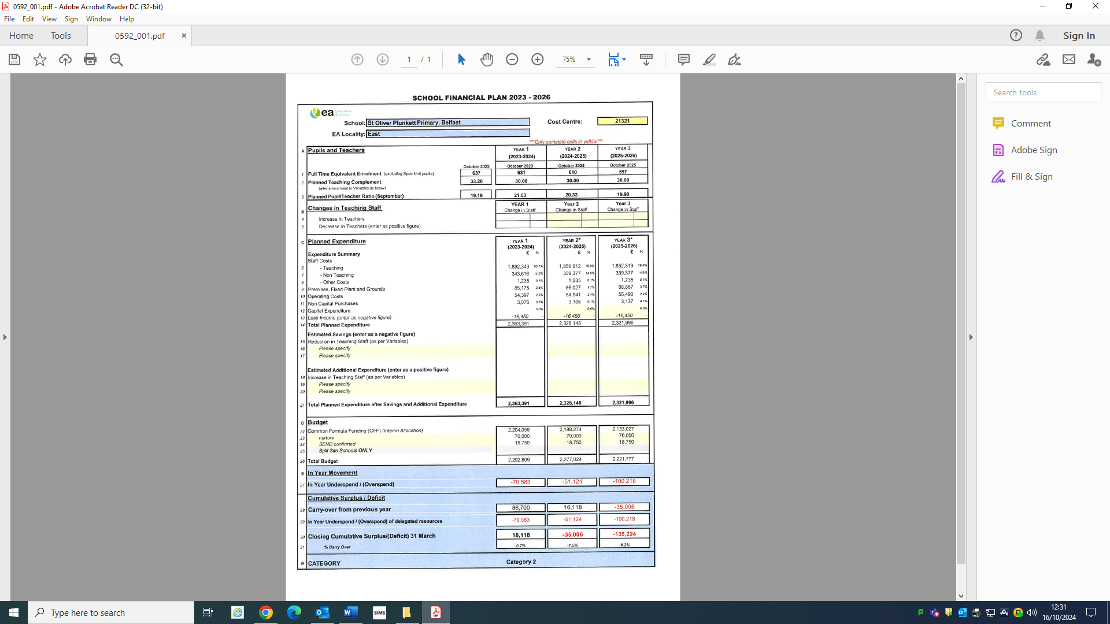
As of the date of publication of this School Development Plan, we are still in line with our spending projections.

3. An assessment of –
(b) The planned use of the school’s projected resources during the period covered by the plan in support of actions to bring about improvements in standards;
The budget has been very much utilised to impact upon areas identified as priorities within the School Development Plan.
The vast majority of budget is directed at the “chalkface” to meet the needs of pupils, to recognise the pressures that staff are under and that is in ensuring as low a PTR as possible.
This we do as we believe this allows us the best opportunity to combat the effects of child poverty and all its negative impacts upon the well-being, aspirations and attainments of our children.
At the date of this SDP we had 634 pupils in 26 classes giving us an actual PTR of 24.38.
Unfortunately, as previously stated due to the reality of the N.I. Education Budget we are aware that we may be pressured into folding classes. The problem is those bigger numbers do not allow for the dilution of complex needs across the year band. They bring too many children with complex needs into the one classroom, that will inevitably lead to more stress upon the shoulders of staff and a negative impact on the learning experiences of all of the other children in the classroom.
We continue where possible to purchase additional resources in the key areas of literacy, numeracy and ICT.

4. An assessment of the extent to which the school has met its key targets, or the progress that has been made towards these key targets in any school development plan which a school development plan supersedes or revises.
As stated at the outset of this SDP document, this cycle will reflect the reality of a number one year interim SDPs and the impact of Covid-19 lockdowns over two years.
This is a new baseline; it is my assertion that the target over the last few years taking into consideration Covid lockdowns and major Industrial Action has been to keep the school open and to ensure high aspirations for our children.
There is a necessity too to recognise that impact, for example pre-Covid our average attendance sat at 95% where as the starting point for this it had fallen to 89.1%.
We continue to develop as a reflective school from the planning, assessing, evaluating, remediating structures that we have developed, to our vertical and horizontal monitoring processes that include Collegial Book Discussions and Trusted Colleague Networking to improve our practices and outcomes. We have worked tirelessly to minimise the impact of any Covid outcome gaps but this new SDP cycle allows us to put solid, meaningful targets in place.
These targets formed from the baselines that we will measure our success at the end of this cycle.

Literacy Target 23-26.
The primary target for the duration of this School Development Plan is focussed on the number of children in the Below Average Stanines and equally those in the Above Average Group.

The opening baseline is 27% for the Below Average and 18% in the Above Average. You can see that there has already been a reduction in the Below Average group from 30% in 2022 to 27% in 2023.

The target for this grouping will be to come in line with the National Expected of 23% by the end of this cycle. Furthermore, the Above Average cohort has maintained at 18% over the past two years, the target will be to increase the outcome to 21%.

The subsidiary target will be to home in on those children who are in Stanines Three and Four as well as Stanines Six and Seven.

The aim is straightforward it is to try to identify pupils at an individual level who can be targeted in Stanine Three with a potential to move to Four and therefore impacting upon the Bell Curve outcomes for the school, as well as most importantly the child.

We will also target individual children in Stanine Four who are at risk of slipping into the Below Average group and thus negatively impacting upon the school profile.

Furthermore, we will look at those children in Stanine Six who have the potential to move into the Above Average category whilst also targeting those in Seven who may drop back into the Average grouping.

The population of Stanine Three in Literacy is 12% we want to reduce that over the course of SDP cycle to 9%. We wish to increase Four accordingly and enhance it to a minimum of 23% from 21%. We will set an ambitious target of increasing the Above Average Stanine Seven percentage from 10% to 15% which will bring the Above Average in line with the National Expected.

Numeracy Target 23-26.

The primary target for the duration of this School Development Plan is focussed on the number of children in the Below Average Stanines and equally those in the Above Average Group.

The opening baseline is 25% for the Below Average and 16% in the Above Average. You can see that there has already been a reduction in the Below Average group from 30% in 2022 to 25% in 2023.

The target for this Below Average grouping will be to come in line with the National Expected of 23% by the end of this cycle. Furthermore, the Above Average cohort has maintained at 16% over the past two years, the target will be to increase the outcome to 20%.

The subsidiary target will be to home in on those children who are in Stanines Three and Four as well as Stanines Six and Seven.

The aim is straightforward it is to try to identify pupils at an individual level who can be targeted in Stanine Three with a potential to move to Four and therefore impacting upon the Bell Curve outcomes for the school, as well as most importantly the child.

We will also target individual children in Stanine Four who are at risk of slipping into the Below Average group and thus negatively impacting upon the school profile.

Furthermore, we will look at those children in Stanine Six who have the potential to move into the Above Average category whilst also targeting those in Seven who may drop back into the Average grouping.

The population of Stanine Three in Numeracy is 12% we want to reduce that over the course of SDP cycle to 10%. We wish to increase Four accordingly and enhance it to a minimum of 21% from 19%. We will set an ambitious target of increasing the Above Average Stanine Seven percentage from 10% to 14% which will bring the Above Average to 20%.

OUR CHALLENGES SDP 23/26
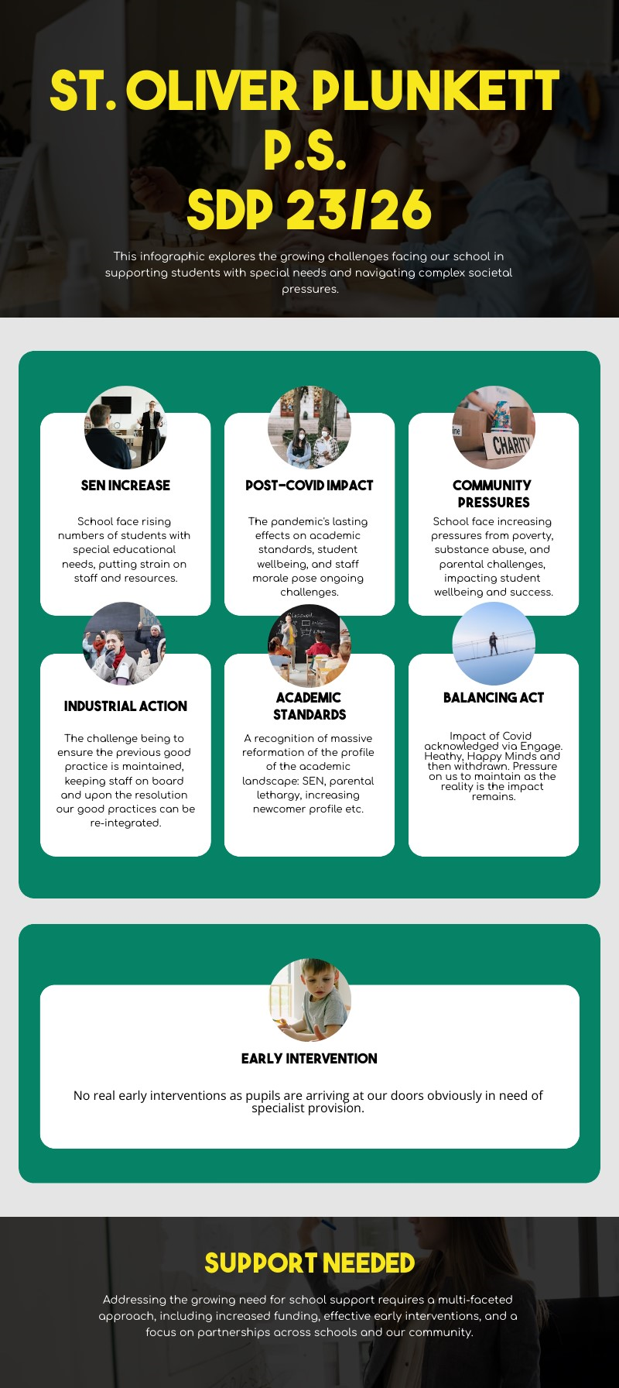
5. An assessment of the challenges and opportunities facing St. Oliver Plunkett Primary School
“We know that for some schools the challenge is greater than for others. We recognise, through this policy, that those schools serving disadvantaged communities, and communities where the value placed on education may not be as high as it might be, will need much greater levels of support. We know, too, that teachers often want and need to spend proportionately more time and resources supporting those pupils who are at particular risk of educational underachievement and we want to help them to do this.”

Every School A Good School. DENI. 2009

The challenges that we as a school have, remain, unfortunately, consistent from the last SDP. These socio economic challenges are not going to dissipate. We are still a community immersed in social deprivation and we deal with the ramifications of that deprivation on a daily basis.

The Table below from the Institute for Fiscal Studies Briefing Note 154 entitled “Child and working-age poverty in Northern Ireland over the next decade: an update” highlights the levels of children living in relative and absolute poverty and the projected growth of those numbers.
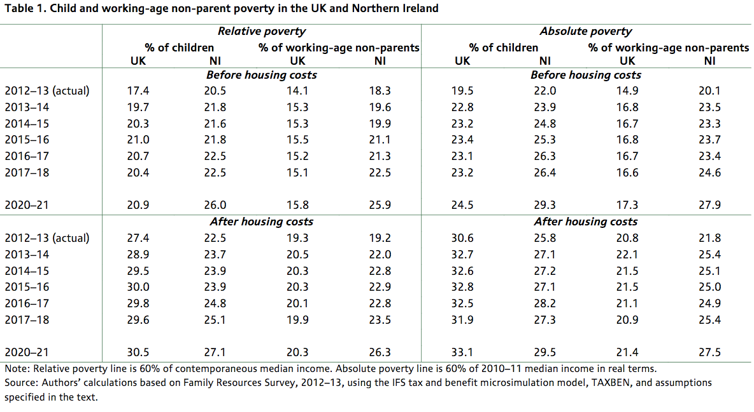
The figures above tell their own tale, however the reality of our children can be drilled down furter with an insight into where we exist. Our statistics are more negative than those above.

We exist within the Parliamentary Constituency that is rated second in Northern Ireland with respect to levels of children in poverty; Foyle 34.38%, Belfast West 33.91%.

Upon greater analysis our reality becomes all the harsher, the Collin Glen ward from which a high percentage of our pupils come has 49.19%* of children existing in poverty; that is the highest negative percentage of all wards within the West Belfast constituency.
*The figures are taken from the End Child Poverty study.
www.endchildpoverty.org.uk
The implications that we face on a daily basis due to the reality we find ourselves in; was the major contributing driving force in the last SDP and the various initiatives that were undertaken, is currently in the formation of this new SDP and will be in the future as we try to ensure that our children are given the best possible outcomes and subsequently the best possible opportunities for holistic success in their futures.
St. Oliver Plunkett Primary School is situated in the 47th of 890 Super Output Areas in Northern Ireland.
65+% of our pupils are entitled to Free School Meals.
90+% of our pupils are from Neighbourhood Renewal Areas.
This is our reality and there is a mature realisation that the reality impacts upon what we do, how we do it and even more importantly why we do it.
http://www.ted.com/talks/simon_sinek_how_great_leaders_inspire_action
We take heart in the findings of the ‘Investigating Links in Achievement and Deprivation’ (the ILiAD study) undertaken by Queen’s University Belfast and the subsequent findings that children from socially deprived areas can outperform the expectations.
https://www.qub.ac.uk/research-centres/CentreforSharedEducation/Filestore/Filetoupload,775013,en.pdf

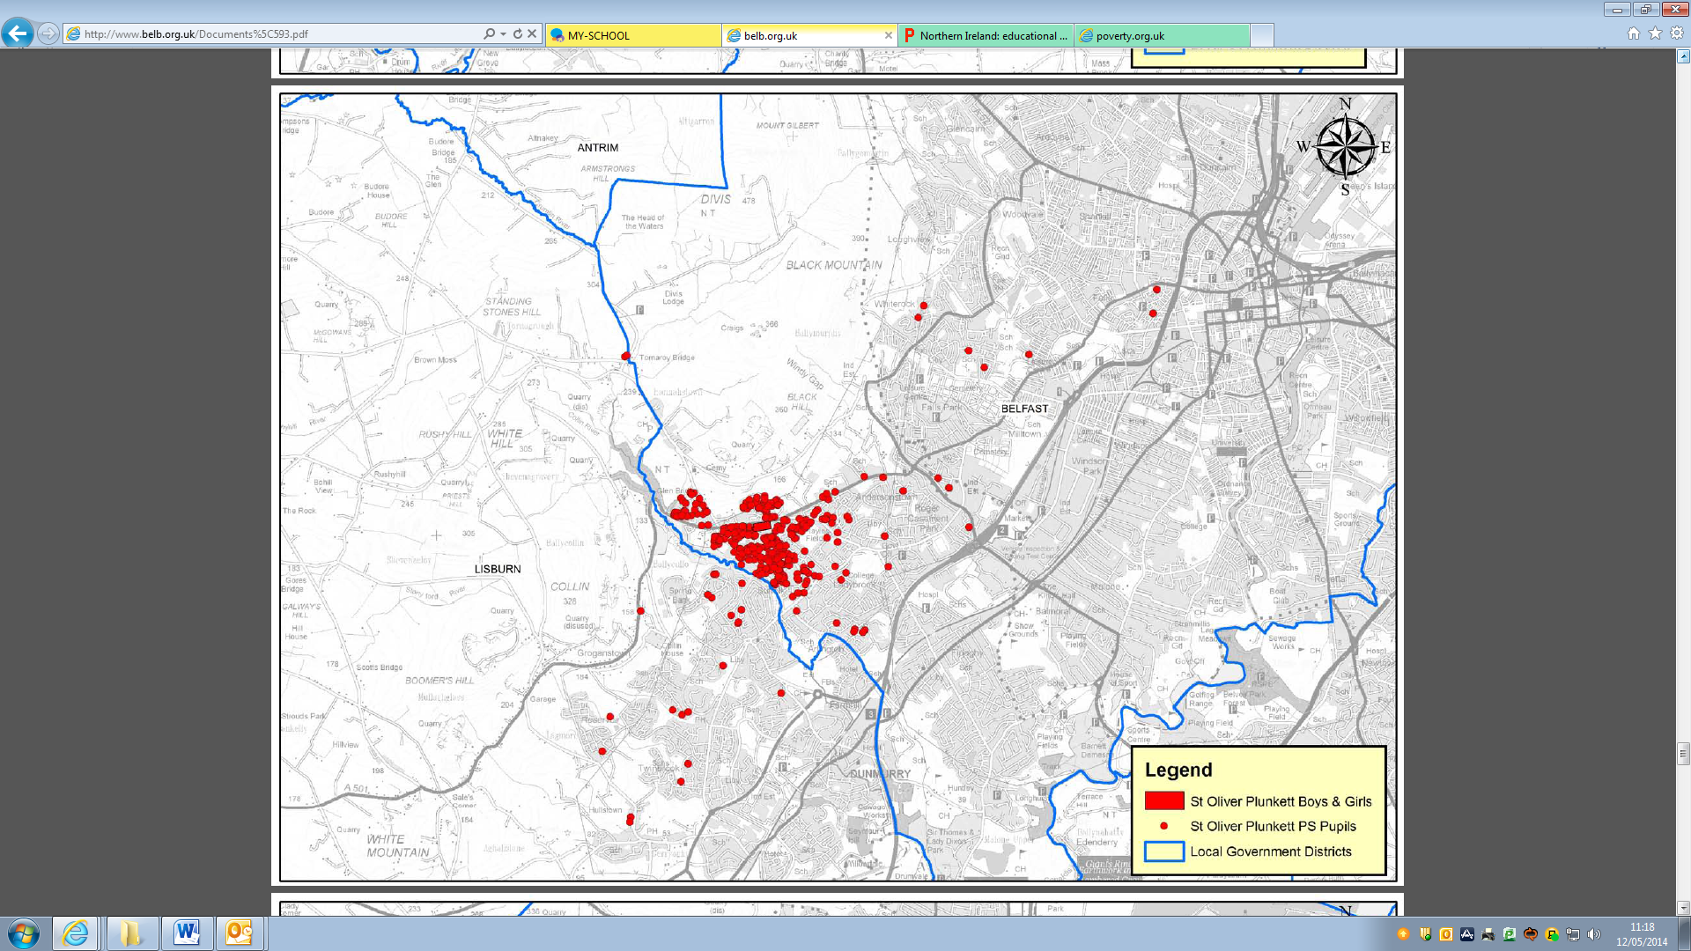
St. Oliver Plunkett pupil distribution as mapped for the BELB Draft Area Plan, March 2013.
The NIMDM 2010 provides information on seven types or ‘domains’ of deprivation and an overall multiple deprivation measure comprising a weighted combination of the seven domains.

The NIMDM 2010 is a combination of all seven deprivation domains, weighted as follows:

■ Income Deprivation 25%

■ Employment Deprivation 25%

■ Health Deprivation and Disability 15%

■ Education Skills and Training Deprivation 15%

■ Proximity to Services 10%

■ Living Environment 5%

■ Crime and Disorder 5%

The weights attributed to each of the domains are as per the NIMDM 2005 and were determined by the robustness of indicator data, user consultation and considerations of theory on models of multiple deprivation.

Education, Training and Skills Deprivation measures the extent of deprivation in education, skills and training, by Super Output Area, for both children and working age adults. Measures include:

• Educational outcomes, such as attainment at Key Stage 2, Key Stage 3 and GCSE level;
• Absenteeism at primary and post-primary schools;
• Proportions of pupils attending Special Educational Needs schools or with Special Educational Needs Stages 3 – 5
• Proportions of 18 – 21 year olds who have not enrolled in Higher
Education Courses at Higher Education or Further Education
Establishments;
• Proportions of working age adults (25-59) with no or low levels of qualification

Table1 shows our Super Output Area’s Education Deprivation ranking.

Super Output Area | School Name | Education, Skills and Training Deprivation
Glencolin_4 | St Oliver Plunkett Primary | 64

Neighbourhood Renewal Areas are those neighbourhoods in the most deprived 10% of wards across Northern Ireland. This includes a total of 36 areas with a population of approximately 280,000 (i.e. one person in 6 in Northern Ireland).

Of those schools in Northern Ireland that have 51% or more of pupils living in a Neighbourhood Renewal Area, 53% of the primary schools are in the old Belfast Education and Library Board designation; 65% of post primary schools with this designation are in the old BELB.

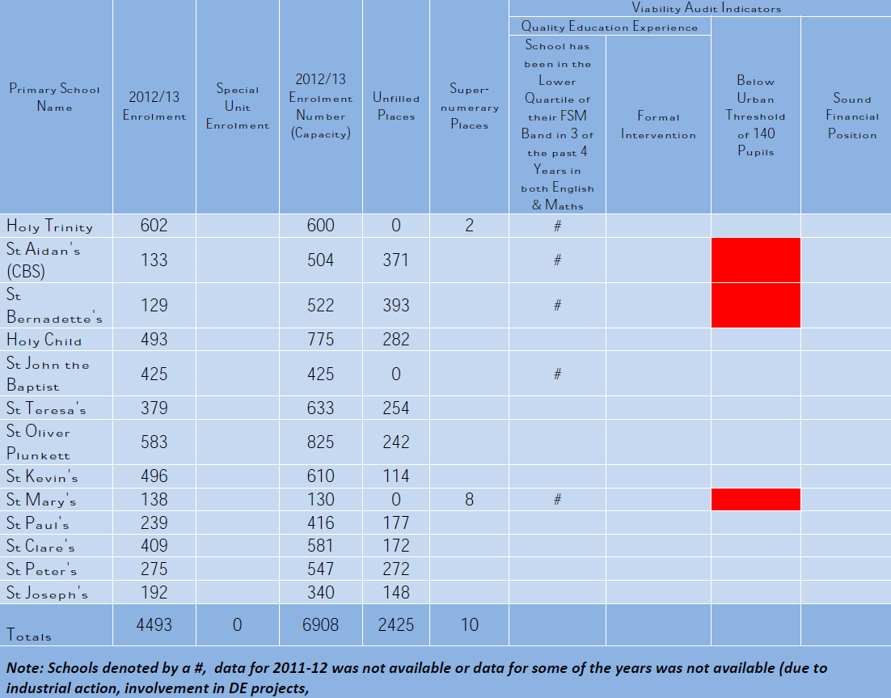
Table 3 above provides a summary of the viability audit, 2012-2013 enrolment, capacity and unfilled places for the West Belfast Maintained Cluster, taken from the BELB Draft Area Plan of March 2013.

There is a distinct correlation between the information above and the focus of our School Development Plan, including expenditure decisions. It is imperative upon us as a school to give our children the best opportunities that they can avail of, to succeed academically and develop holistically.

This is our primary challenge; to overcome those challenges that we will meet on a daily, weekly, termly and annual basis based upon the reality of our context.

Additional challenges;
Challenge of ever more complex needs

Attendance

Lack of CASS//CPD/TPL

Lack of Visionary Strategic leadership

Finances

The Opportunities

The Opportunities that exist as we begin our School Development Plan journey are plentiful; however they will continue to be detrimentally impacted upon by decreasing budget, increasing issues to be faced, drop in roll numbers which impacts further upon budgetary concerns and so the cycle continues.

There is however a recognition that the plentiful challenges force us to be as creative as we possibly can to meet those challenges.

They can be best summed up in the infographic below, entitled, “Opportunity Road.”
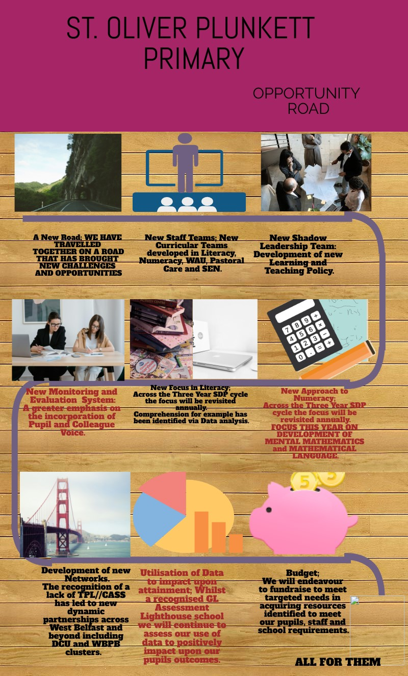
6. The arrangements made by the Board of Governors to consult and take account of the views of pupils, parents, staff and other persons or bodies in the preparation of the plan.
As a school grounded in the UNICEF Rights Respecting ethos, the Voice of the Pupil has been, and is being developed. We take account oof the views of our children through the normal discourse of their learning, through them being actively and centrally involved in the new Monitoring and Evaluation process and for the purposes of this SDP via questionnaires issued to every pupil in KS2. Additionally, all of our pupils from Years Four to Seven undertake PASS survey.
Parents completed questionnaires at Parent Interviews in November; their views have been feedback to Governors and incorporated into this plan.
Teaching staff too were issued questionnaires.
A cohort of Teaching Assistants rep[resenting each of the year bands meet regularly with the principal.
There are systematic procedures in place by the Board of Governors to review the School Development Plan and its Action Plans throughout the course of the life of this Plan, including meeting with Curricular Leaders and Coordinators in Term Three to review Annual Action Plans.

Section 7 Identification of the areas for development, which shall be informed by the school’s self-evaluation and include
- The school’s key priorities for the period of the plan, based on the Department’s priorities for education;
Key Areas for Development for School Development Plan 2023-26
AREA | ASPECT | DEVELOPMENT | TIMING
Literacy | To raise standards in Language and Literacy through a continued and monitored focus on Writing and Reading | See Accompanying Action Plan | September 2023- June 2026 as part of three-year programme.
Numeracy | To raise standards in Mathematics and Numeracy through a heightened and monitored focus on Mental Maths and development of mathematical language. | See Accompanying Action Plan | September 2023- June 2026 as part of three-year programme.
Play Based Learning | To develop new Play Planning and Observations initially in Foundation Stage and by the end of this cycle into KS 1. | See Accompanying Action Plan | September 2023- June 2026 as part of three-year programme.
Speech and Language at F.S | New programme developed utilising WellComm and Talk Boost combined to target Speech and Lang. deficits. | See Accompanying Action Plan | September 2023- June 2026 as part of three-year programme.
Wellbeing | To continue initiatives such as Art Time, Let’s Shine, Core NI, School Counsellor and to introduce new initiatives such as the Therapy Dog and The Real Me Academy started during the post Covid period. | See Accompanying Action Plan | September 2023- June 2026 as part of three-year programme.
SEN | To disseminate the SEN practices from the SPIM re: ASD to all classrooms. To disseminate the Nurture practices developed in the Nurture Room across the school. | See Accompanying Action Plan | September 2023- June 2026

Section 7 Identification of the areas for development, which shall be informed by the school’s self-evaluation and include
- planned outcomes, including planned outcomes in learning, teaching and raising standards of attainment, which, in the case of schools other than nursery and special schools, must include targets for raising standards of attainment in Communication, Using Mathematics and Using ICT;
Literacy Target 23-26.
The primary target for the duration of this School Development Plan is focussed on the number of children in the Below Average Stanines and equally those in the Above Average Group.

The opening baseline is 27% for the Below Average and 18% in the Above Average. You can see that there has already been a reduction in the Below Average group from 30% in 2022 to 27% in 2023.

The target for this grouping will be to come in line with the National Expected of 23% by the end of this cycle. Furthermore, the Above Average cohort has maintained at 18% over the past two years, the target will be to increase the outcome to 21%.

The subsidiary target will be to home in on those children who are in Stanines Three and Four as well as Stanines Six and Seven.

The aim is straightforward it is to try to identify pupils at an individual level who can be targeted in Stanine Three with a potential to move to Four and therefore impacting upon the Bell Curve outcomes for the school, as well as most importantly the child.

We will also target individual children in Stanine Four who are at risk of slipping into the Below Average group and thus negatively impacting upon the school profile.

Furthermore, we will look at those children in Stanine Six who have the potential to move into the Above Average category whilst also targeting those in Seven who may drop back into the Average grouping.

The population of Stanine Three in Literacy is 12% we want to reduce that over the course of SDP cycle to 9%. We wish to increase Four accordingly and enhance it to a minimum of 23% from 21%. We will set an ambitious target of increasing the Above Average Stanine Seven percentage from 10% to 15% which will bring the Above Average in line with the National Expected.

Numeracy Target 23-26.

The primary target for the duration of this School Development Plan is focussed on the number of children in the Below Average Stanines and equally those in the Above Average Group.

The opening baseline is 25% for the Below Average and 18% in the Above Average. You can see that there has already been a reduction in the Below Average group from 30% in 2022 to 27% in 2023.

The target for this Below Average grouping will be to come in line with the National Expected of 23% by the end of this cycle. Furthermore, the Above Average cohort has maintained at 16% over the past two years, the target will be to increase the outcome to 20%.

The subsidiary target will be to home in on those children who are in Stanines Three and Four as well as Stanines Six and Seven.

The aim is straightforward it is to try to identify pupils at an individual level who can be targeted in Stanine Three with a potential to move to Four and therefore impacting upon the Bell Curve outcomes for the school, as well as most importantly the child.

We will also target individual children in Stanine Four who are at risk of slipping into the Below Average group and thus negatively impacting upon the school profile.

Furthermore, we will look at those children in Stanine Six who have the potential to move into the Above Average category whilst also targeting those in Seven who may drop back into the Average grouping.

The population of Stanine Three in Numeracy is 12% we want to reduce that over the course of SDP cycle to 10%. We wish to increase Four accordingly and enhance it to a minimum of 21% from 19%. We will set an ambitious target of increasing the Above Average Stanine Seven percentage from 10% to 14% which will bring the Above Average to 20%.

UICT Target 22-26

The target will be simple; it will reflect our technology stock reality and the impact that it will have on our ability to undertake tasks that in the past were quite natural.

Our iPad stock has been greatly depleted by age. We have opened an ICT suite but the transition from tablet devices to desktops will take staff this SDP cycle to come to terms with.

Our target will be to revise our lines of development to reflect more desktop activities. The subsidiary target will be to go through the process of retaining our 360 degree e-safety Award.

Section 7 Identification of the areas for development, which shall be informed by the school’s self-evaluation and include
- the actions to be taken to achieve the outcomes mentioned at sub-paragraph (b) and final dates for completion;

The School Development Plan curricular targets will be evaluated and reviewed through the use of comparative like for like data on an annual basis from May onwards. This will allow us to measure our success and to target with precision those areas that require development.

We have a target setting model in place that allows for the development of Whole School Targets, Key Stage, Year Group, Annual Class Targets and individual target setting for Underachieving children based upon analysis of standardised data and with the input of staff subjective judgement.

In addition to this Target Setting model we have developed a thorough Monitoring and Evaluation programme as well as the Internal Moderation of standards on a Half Termly basis via a new model that incorporates Collegial Book Discussions as well as the Pupil Voice.
As well as utilising PRSD as a vehicle in school improvement. On a more informal basis, staff are timetabled to share books on a weekly basis through their planning meetings.
It is our hope that this package will impact positively upon standards of teaching and learning.

LITERACY TARGETS

The Graphic above is an illustration of the aim of the Literacy aspect of this SDP. The link shows the why behind the focus, the strategies required and the tools that are used to develop those strategies.

As stated in several of the above sections:
The primary literacy target for the duration of this School Development Plan is focussed on the number of children in the Below Average Stanines and equally those in the Above Average Group.

The opening baseline is 27% for the Below Average and 18% in the Above Average. You can see that there has already been a reduction in the Below Average group from 30% in 2022 to 27% in 2023.

The target for this grouping will be to come in line with the National Expected of 23% by the end of this cycle. Furthermore, the Above Average cohort has maintained at 18% over the past two years, the target will be to increase the outcome to 21%.

The subsidiary target will be to home in on those children who are in Stanines Three and Four as well as Stanines Six and Seven.

The aim is straightforward it is to try to identify pupils at an individual level who can be targeted in Stanine Three with a potential to move to Four and therefore impacting upon the Bell Curve outcomes for the school, as well as most importantly the child.

We will also target individual children in Stanine Four who are at risk of slipping into the Below Average group and thus negatively impacting upon the school profile.

Furthermore, we will look at those children in Stanine Six who have the potential to move into the Above Average category whilst also targeting those in Seven who may drop back into the Average grouping.

The population of Stanine Three in Literacy is 12% we want to reduce that over the course of SDP cycle to 9%. We wish to increase Four accordingly and enhance it to a minimum of 23% from 21%. We will set an ambitious target of increasing the Above Average stanine percentage from 10% to 15% which will bring the Above Average in line with the National Expected.

To assist in the development of the Reading process we have developed a new Library. We had applied for and were successful in getting a grant for £10,000. The library will open in year one of the SDP cycle. We will continue ot purchase additional reading materials where identified by coordinators to fill in gaps in either the core reading scheme or additional Accelerated Reading levels.

To highlight the place that Reading will have moving through this cycle Comprehension is a noted priority over the next three years. It will be scrutinised each year via PTE outcomes.

The development of the Writing process will continue to be monitored as the likelihood is that we will need to begin the process of identifying and purchasing a new Writing scheme during the duration of this SDP.
Additionally, the IEN (Identified Educational Need) package, diluted as it is, will continue to tackle Underachievement in literacy and numeracy.

It is our aim to positively impact upon our Data profile through our continuous analysis of data; through target setting on a school, key stage, year group, class level as well as identifying Individual pupils who are deemed to be Underachieving or indeed Low Attaining.

NUMERACY TARGETS

The Graphic above is an illustration of the aim of the numeracy aspect of this SDP. The link shows the why behind the focus, the strategies required and the tools that are used to develop those strategies.

The primary target for the duration of this School Development Plan is focussed on the number of children in the Below Average Stanines and equally those in the Above Average Group.

The opening baseline is 25% for the Below Average and 18% in the Above Average. You can see that there has already been a reduction in the Below Average group from 30% in 2022 to 27% in 2023.

The target for this Below Average grouping will be to come in line with the National Expected of 23% by the end of this cycle. Furthermore, the Above Average cohort has maintained at 16% over the past two years, the target will be to increase the outcome to 20%.

The subsidiary target will be to home in on those children who are in Stanines Three and Four as well as Stanines Six and Seven.

The aim is straightforward it is to try to identify pupils at an individual level who can be targeted in Stanine Three with a potential to move to Four and therefore impacting upon the Bell Curve outcomes for the school, as well as most importantly the child.

We will also target individual children in Stanine Four who are at risk of slipping into the Below Average group and thus negatively impacting upon the school profile.

Furthermore, we will look at those children in Stanine Six who have the potential to move into the Above Average category whilst also targeting those in Seven who may drop back into the Average grouping.

The population of Stanine Three in Numeracy is 12% we want to reduce that over the course of SDP cycle to 10%. We wish to increase Four accordingly and enhance it to a minimum of 21% from 19%. We will set an ambitious target of increasing the Above Average stanine percentage from 10% to 14% which will bring the Above Average to 20%.
Numeracy and the development of Mental Maths and problem solving will be an integral part of the PRSD process this year and will be monitored through weekly year group meetings informally and formally through classroom observations of Mental Maths sessions. Mental Maths will be monitored rigorously through analysis of data too.
It is our desire that our children are engaged in Mathematics from an early age.
http://mobile.nytimes.com/2014/07/25/opinion/dont-teach-math-coach-it.html?_r=1&referrer
The above link sums up the aim that we should connect with the child’s natural inquisitiveness and not dampen it through the pressures of content coverage that is unrelated to their experiences. In essence, the challenge for our staff is to be creative.
The link below is an insight in to the challenge that we as an education community face and not just us as a school.
http://www.ted.com/talks/dan_meyer_math_curriculum_makeover
It is our aim to positively impact upon our Data profile through a thorough analysis of data, through target setting on a school, key stage, year group, class level as well as identifying Individual pupils who are deemed to be Underachieving or indeed Low Attaining. In the following years, we will add a layer to this package that will identify High Attaining pupils and target their needs.
In light of the ongoing industrial action regarding the Levels of Progression there has been no reliable available data from 2013-14.

WELLBEING.

Section 7 Identification of the areas for development, which shall be informed by the school’s self-evaluation and include
- the financial and other resources available to the school to be used in support of the actions identified at sub-paragraph (c) to achieve the outcomes identified at sub-paragraph (b);
The expenditure of the budget has been wholly focussed on the SDP targets, in essence to improve standards across our school, to measure the impact of our teaching and the children’s learning.

Section 7 Identification of the areas for development, which shall be informed by the school’s self-evaluation and include
- the arrangements for the Board of Governors, in consultation with the principal, to monitor, review and evaluate progress made against the school development plan
The School Development Plan will be a permanent agenda point at all Board of Governor meetings. The Principal has formed a Sub Committee of the Board of Governors focussed on Education: SDP and its targets.
It will be the remit of this subcommittee to meet with the Principal and the creators of the Action Plans to ascertain whether progress is being made towards meeting the SDP targets.
There will be a Board of Governors meeting set aside in May that will be purely focussed on SDP progress, all Action Plan authors will present to the Governors and be available for discussions based on the SDP Action Plans.
The Principal will report to the Board of Governors on the analysis of internal Standardised Tests to ascertain whether targets have been met in Communication and Using Mathematics.

Appendix One
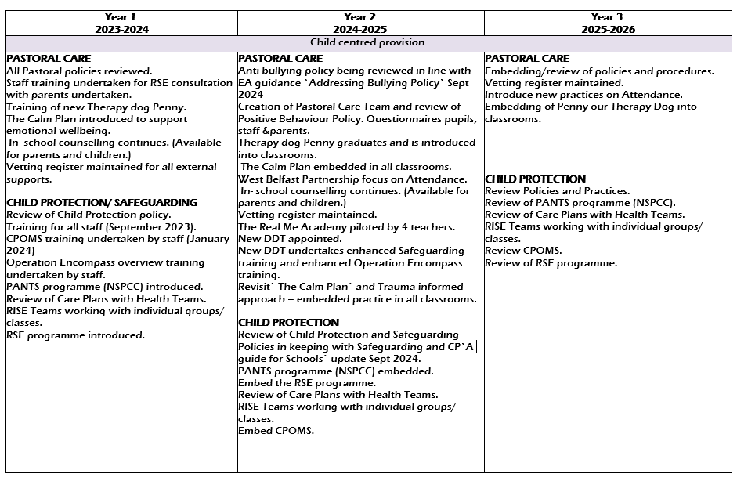
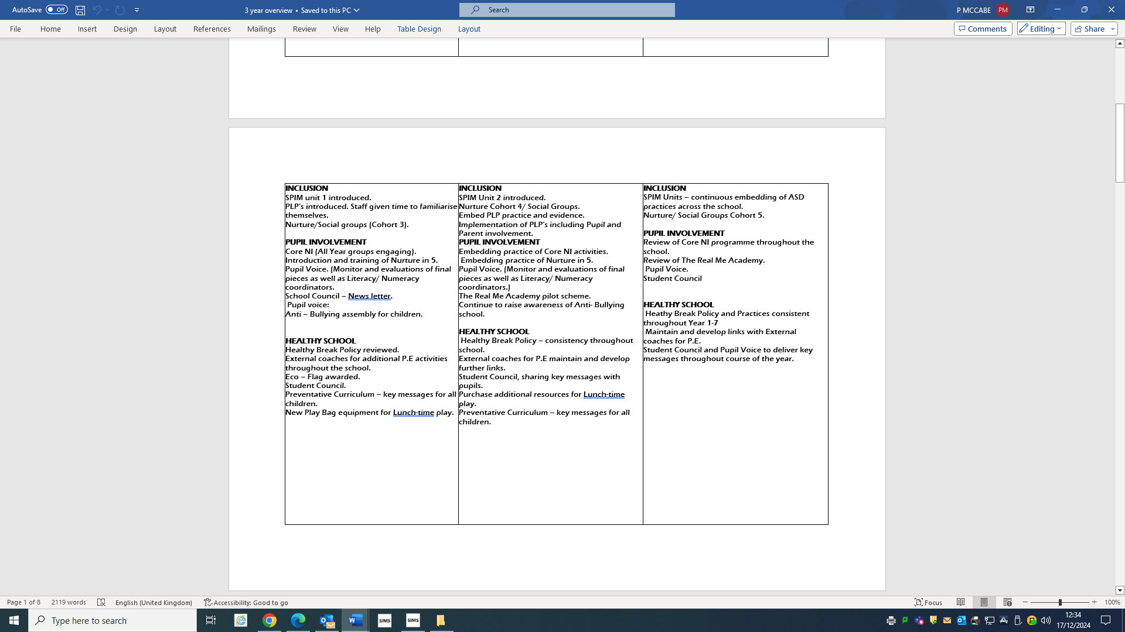

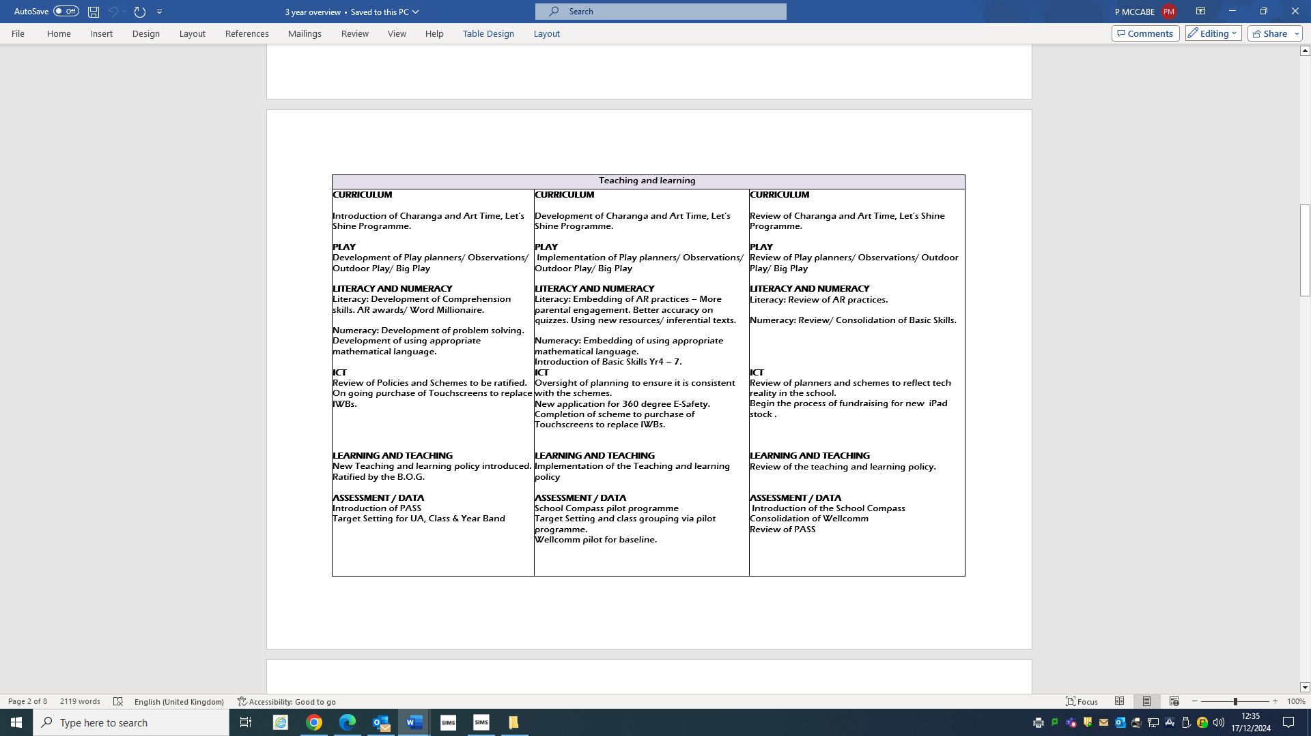
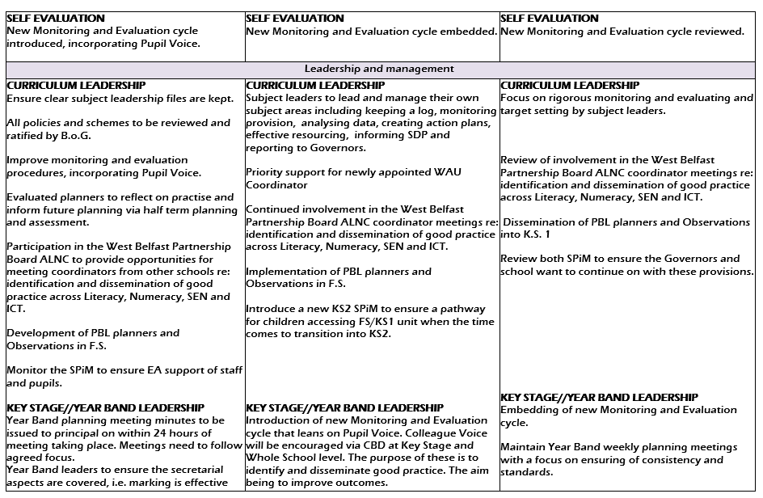

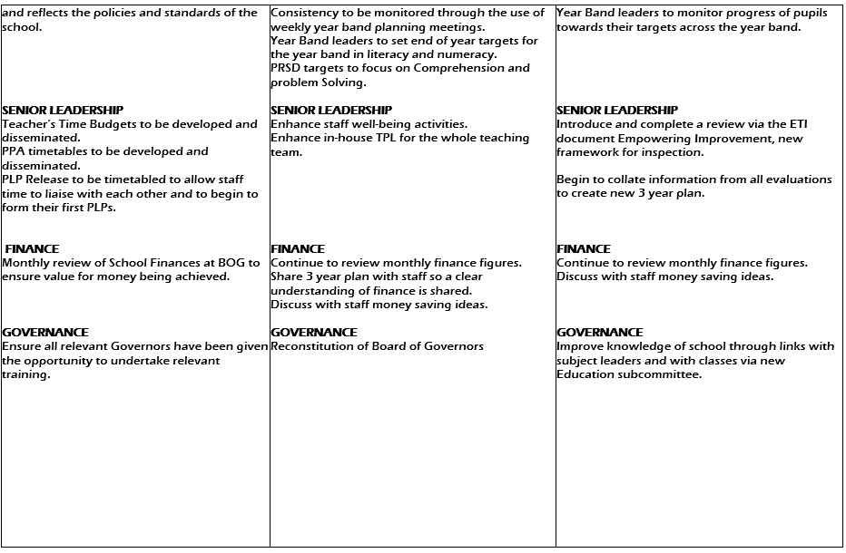
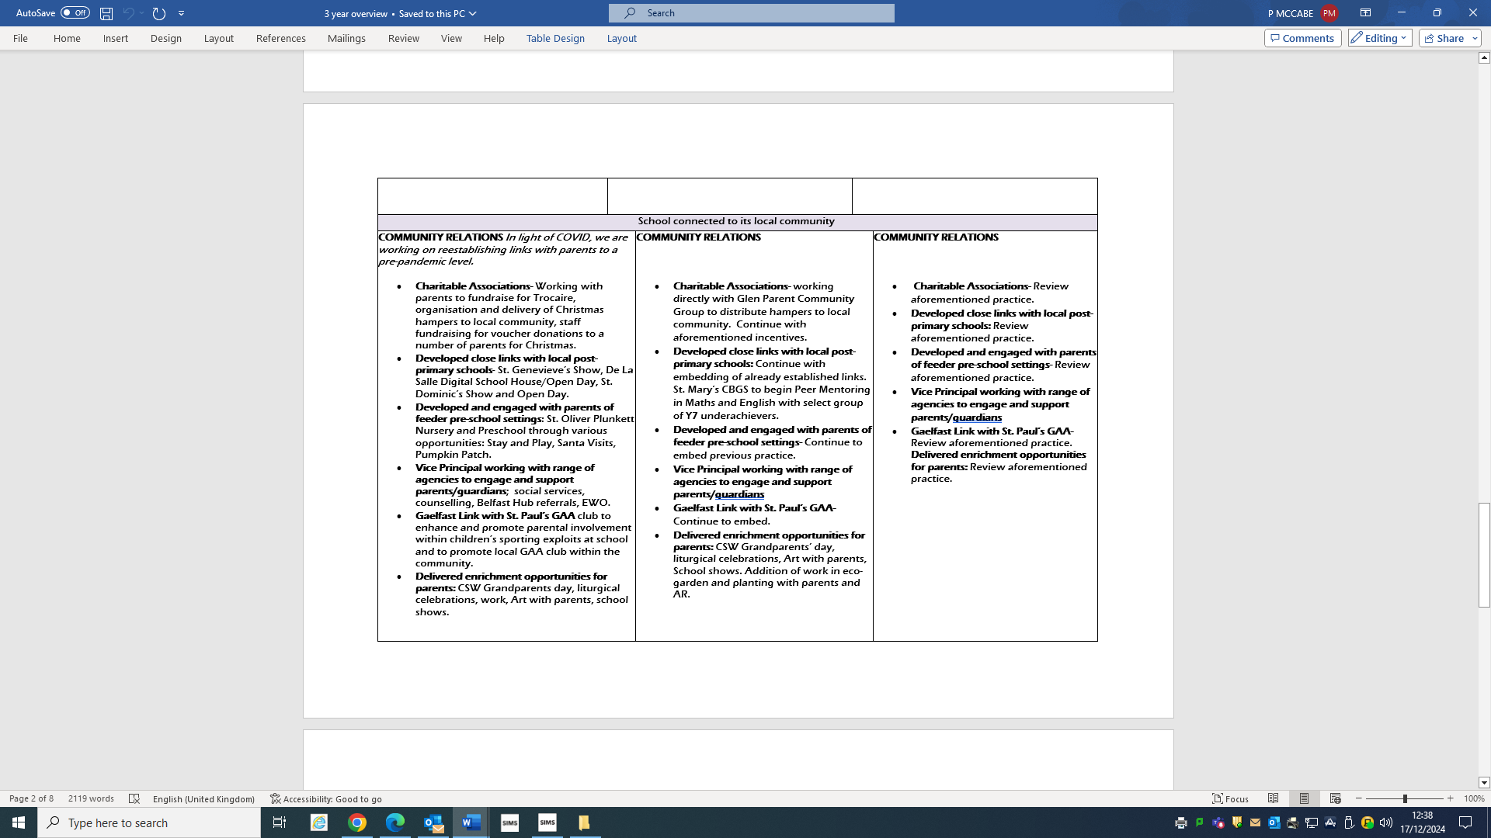

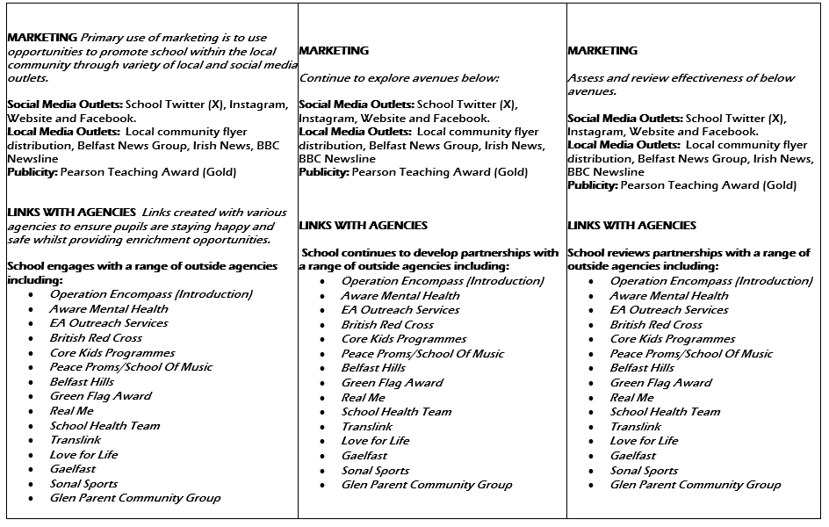

Appendix Two

PUPIL VERSION OF SDP 2024/25

If I am worried, who can I talk to?

Mrs. Roche

- Designated Teacher

Mrs. Hanna
Mrs. Diamond
- Deputy Designated Teachers

OUR SCHOOL’S HOPE THIS YEAR, THAT WE…
LITERACY.
- Develop our comprehension skills.
- Develop our ability to listen to and ask questions that allow us to get information that we might need.
- We will get the opportunity to talk with teachers about our learning in Literacy.
NUMERACY.
- Develop our problem solving skills.
- Develop our ability to solve word problems.
- Develop our use of mathematical language.
- We will get the opportunity to talk with teachers about our learning in Numeracy.

OUR SCHOOL’S HOPE THIS YEAR, THAT OUR TEACHERS…
PLAY BASED LEARNING.
- Will observe how we play and how we play with each other.
- Will help us to develop our speech and our vocabulary.
PASTORAL CARE.
- Will work to develop a new Anti-Bullying Policy. They will take on board our views when it is being developed.
- Will work to develop a new Positive Behaviour Policy. They will take on board our views when it is being developed.

Appendix Three
QUICK REFERENCE PARENT VERSION OF THE SCHOOL DEVELOPMENT PLAN Year 2 2024/25.

SCHOOL DEVELOPMENT PLAN
2023 – 2026
Mission Statement
Our mission is to serve the children, families and wider school community through delivering high quality learning and teaching across, all aspects of the curriculum, for all children, in a nurturing, positive environment. (UNCRC Article 3)
We have high expectations for children and staff. We build confidence by providing opportunities for daily success and celebrate the achievements of all. Through a collegial approach to effective planning and delivery, we build trust and respect and enable the gifts and talents of children and staff to develop fully. NCRC Article 29)

KEY PRIORITIES.
- School website
www.stoliverplunkettprimary.org

Curriculum Targets
- Literacy
- Development of non-narrative comprehension.
- Development of Inferential Skills.

- Numeracy
- Development of Problem Solving Skills
- Development of Word Problems

- Learning through Play
- Embedding of Play Planners and Resources in FS.
- Development of new Speech and Language assessment package incorporating WellComm and Talk Boost in Foundation Stage.

- Special Educational Needs
- SENCO continues to ensure there is early identification of pupils with specific needs
- New PLP to be developed, reflected upon and embedded taking into consideration pupil and parent voice.

LEADERSHIP & MANAGEMENT
- Data Collection
- Use of internal tests to set targets in Numeracy and Literacy on a Year Band, class and individual pupil basis.
- Development of new Website to more readily identify individual pupils or groups and to ensure pupils are placed in the correct ability groups.

- Pastoral Care
- Pastoral Team to review and develop new Anti Bullying Policy and Positive Behaviour Policy.
- Designated Teacher is Mrs. Roche
- Deputy-Designated Teachers are Mrs. Hanna and Mrs. Diamond
- Deputy-Designated Teacher for C.P. with a focus on E-Safety is Miss McCabe
- Our current Governor for Child Protection is Fr. McAleese.
- New Pastoral Care Team formed.

- Teaching & Learning
- New Learning and Teaching policy devised and ratified by B.O.G. This policy has been added to the school website.
- Curriculum teams in Literacy, Numeracy, ICT and Assessment formed.
- A new Monitoring & Evaluating structure to include Pupil Voice as an integral part.

- Area of the Curriculum Leaders
- Numeracy – Ms. Mohan and Mrs. Hanna
- Literacy – Ms. McNeill and Mrs. Stuart
- SEN – Mrs. Roche
- The World Around Us – Mr. Reid
- ICT – Mrs. McCullagh and Miss McCabe
- Assessment – Mrs. Hanna and Mr. McBride
- Art – Mrs. Kavanagh
- Music – Mr. Flanagan
- PDMU – Mrs. Diamond
- P.E. – Mr. Muldoon
- Religion – Mr. McBride

