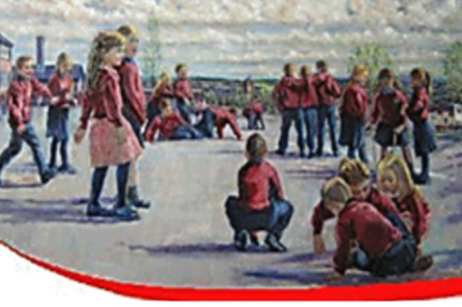

St. Oliver Plunkett Primary School
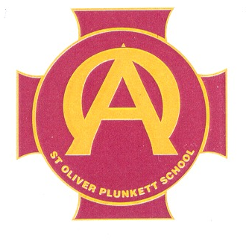
Social Networking Policy

Introduction to the Policy

The school is aware and acknowledges that increasing numbers of adults and children are using social networking sites including among others, Facebook, Twitter, Snapchat, and Instagram.

The widespread availability and use of social networking applications bring opportunities to understand, engage and communicate with audiences in new ways. It is important that we are able to use these technologies and services effectively and flexibly. However, it is also important to ensure that we balance this with our reputation.

This policy and associated guidance is to protect staff and advise school leadership on how to deal with potential inappropriate use of social networking sites. For example, our use of social networking applications has implications for our duty to safeguard children, young people and vulnerable adults.

The policy requirements in this document aim to provide this balance to support innovation whilst providing a framework of good practice.

Purpose

The purpose of this policy is to ensure:

• That the school is not exposed to legal risks
• That the reputation of the school is not adversely affected
• That staff understand the appropriate procedures if they abuse other people or are being abused.

Popular Social Media Platforms

Facebook is targeted at older teenagers and adults. They have a ‘no under 13’ registration policy and recommend parental guidance for 13 to 16 year olds. User’s are required to input their age at registration.

Twitter is targeted at older teenagers and adults. They have a ‘no under 13’ registration policy and recommend parental guidance for 13 to 16 year olds.

Snapchat is targeted at teenagers of all ages and adults. They have a ‘no under 13’ registration policy and recommend parental guidance for 13 to 16 year olds.

Whatsapp is targeted at teenagers 16+ and adults. They have a ‘no under 13’ registration policy.

Youtube is targeted at teenagers 17+ and adults. They have a ‘no under 13’ registration policy.

This guidance is to advise and protect staff from accusations of
improper relationships with pupils:

SCOPE

This policy covers the use of social networking applications by all school stakeholders, including, employees, Governors, parents and pupils. These groups are referred to collectively as ‘school representatives’ for brevity. The requirements of this policy apply to all uses of social networking applications which are used for any school related purpose and regardless of whether the School representatives are contributing in an official capacity to social networking applications provided by external organisations.

Social networking applications include, but are not limited to:

- Blogs, for example Blogger
- Vlogs – example termly school Vlog via Vimeo, Facebook and Twitter
- Online discussion forums, such as netmums.com and Whatsapp
- Collaborative spaces, such as Facebook and Twitter
- Media sharing services, for example YouTube

All school representatives should bear in mind that information they share through social networking applications, even if they are on private spaces, are still subject to copyright, data protection and Freedom of Information legislation, the Safeguarding Vulnerable Groups Act 2006, as amended by the Protection of Freedoms Act 2012, and other legislation. They must also operate in line with the School’s U.I.C.T. Acceptable Use Policy.

Use of Social networking sites in worktime

Use of social networking applications in work time for personal use only is not permitted, unless permission has been given by the Principal.

Social Networking as part of School Service

All proposals for using social networking applications as part of a school service (whether they are hosted by the school or by a third party) must be approved by the Principal first (for example links to twitter on VLE/website.

Terms of Use

School representatives must adhere to the following Terms of Use. The Terms of Use below apply to all uses of social networking applications by all school representatives. This includes, but is not limited to, public facing applications such as open discussion forums and internally-facing uses such as project blogs regardless of whether they are hosted on school network or not.

Where applications allow the posting of messages online, users must be mindful that the right to freedom of expression attaches only to lawful conduct. St Oliver Plunkett Primary School expects that users of social networking applications will always exercise the right of freedom of expression with due consideration for the rights of others and strictly in accordance with these Terms of Use.
Social Networking applications:

•Must not be used to publish any content which may result in actions for defamation, discrimination, breaches of copyright, data protection or other claim for damages. This includes but is not limited to material of an illegal, sexual or offensive nature that may bring the school, or a representative into disrepute.

• Must not be used for the promotion of personal financial interests,
commercial ventures or personal campaigns

• Must not be used in an abusive or hateful manner

• Must not be used for actions that would put school representatives in breach of school codes of conduct or policies relating to staff.

• Must not breach the school’s Code of Conduct Agreement.

• Must not be used to discuss or advise any matters relating to school
matters, staff, pupils or parents.

• No staff member should have a pupil or former pupil under the age of 18 as a ‘friend’ to share information with.

• Employees should not identify themselves as a representative of the school.

• References should not be made to any staff member, pupil, parent or school activity / event unless prior permission has been obtained and agreed with the Principal.

• Staff should be aware that if their out-of-work activity causes potential embarrassment for the school or detrimentally effects the school’s reputation then The Board of Governors is entitled to take disciplinary action.

• If staff are the recipient of defamatory comments about them on Social Networking sites, made by children, parents or other stakeholders, the Principal should be informed immediately, and contact made to relevant services.
Guidance/protection for staff on using social networking

• No member of staff should interact with any pupil in the school on social
networking sites.

• No member of staff should interact with any ex-pupil in the school on social networking sites who is under the age of 18.

• This means that no member of the school staff should request access to a pupil’s area on the social networking site. Neither should they permit the
pupil access to the staff members’ area e.g. by accepting them as a friend.

• Where family and friends have pupils in school and there are legitimate
family links, please inform the Principal. However, it would not be appropriate to network during the working day on school equipment.

• It is illegal for an adult to network, giving their age and status as a child.

• If you have any evidence of pupils or adults using social networking sites without consent in the working day, please contact the named Child Protection person in school (Mrs F Roche – designated teacher – Or Miss T Carney – designated Online Safety Officer).

• No pupil under 13 should be accessing social networking sites. There is a mechanism on social networks where pupils can be reported via the Help screen; at the time of time of writing this policy the direct link for this is for eg on Facebook is: http://www.facebook.com/help/contact.php?show_form=underage

• No pupil may access social networking sites during the school working day – either on PCs or handheld devices, ipads.

• Pupils are not permitted to use mobile phones in school.

• No pupil should attempt to join a staff member’s areas on networking sites. If pupils attempt to do this, the member of staff is to inform the Principal. Parents will be informed if this happens.

• No school computers are to be used to access social networking sites at any time of day, with the exception that specified staff members who are
Facebook administrators at the request of the Principal.

• Any attempts to breach firewalls will result in disciplinary action being taken by the board of governors.

Cyber Bullying.

• Please report any improper contact or cyber bullying to designated child protection officer as soon as it happens to Mrs F Roche (designated teacher) or Miss T Carney (Designated Online Safety Officer)

• We have a zero tolerance to cyber bullying.

Child protection guidance

If the Principal receives a disclosure that an adult employed by the school is using a social networking site in an inappropriate manner as detailed above they should:

• Record the disclosure in line with their child protection policy.

• Schools must refer the matter to the Social Services who will investigate with the Police.

• If the disclosure has come from a parent, take normal steps to calm the parent and explain processes.

• If disclosure comes from a member of staff, try to maintain
confidentiality.

• The Duty Officer (CCMS / EA) will advise whether the member of staff should be suspended pending investigation after contact with the police. It is not recommended that action is taken until advice has been given.

• If disclosure is from a child, normal processes in the child protection
policy will be followed until a police investigation has been carried out. Failure to adhere to this policy will be considered gross misconduct and can result in disciplinary action being taken against the school representative. This could involve legal action.

