iPads helping embed a lifelong love of learning

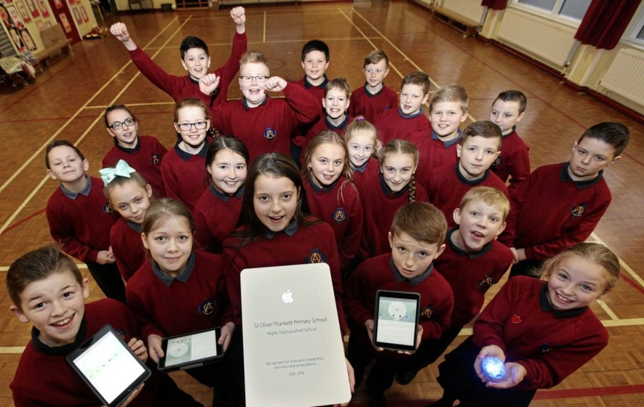
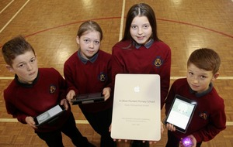
We were among the first in the north to purchase tablet computers for every pupil
Now we have been rewarded for using iPads to engage, encourage, excite and embed a lifelong love of learning, being named an Apple Distinguished School.

The Apple Distinguished School designation is reserved for programmes that meet criteria for innovation, leadership, and educational excellence, and demonstrate a clear vision of exemplary learning environments.
Mr Mc Cabe said that iPad use had an impact and influence in every classroom, breakout area and corridor - "indeed in every aspect of our school".
"The creativity of every class teacher can be seen in how iPad is used as an enrichment tool in the teaching and learning process. I am delighted that parents, pupils and staff received this global recognition from Apple," he said.
"The selection of St Oliver Plunkett PS as an Apple Distinguished School highlights our success as an innovative and compelling learning environment that engages students and provides tangible evidence of academic accomplishment.
"Technological immersion is a reality in which our children exist. It is our challenge to ensure that we too as educators are as immersed as our children. iPad, meshed with the plethora of apps available on the App Store and in the hands of willing, creative teachers who seem themselves as learners, and take every training opportunity available to them ensures that we meet that challenge on a daily basis."

Well done SOP!

